**PROJECT REPORT**

***Generalizable Hate Speech Detection***

*Submitted in partial fulfillment of the requirements*

*for the award of the degree of*

**Master of Computer Application**

**(2024-26, Ist Sem, Batch-1)**

**Under the supervision of:** **Submitted By:**

Dr. Bhawana Pawan Kumar Pandey (S24MCAG0015)

Assistant Professor (CSET) Bhanu Pundir(S24MCAG0049)



**Plot Nos 8-11, TechZone 2, Greater Noida, Uttar Pradesh 201310**

**2024-26**

**ABSTRACT**

The major challenge for automatic hate speech detection is to tell the difference between hate speech and offensive language. Presently adopted word-based detection methods often label any message having some sort of words as hate speech, and this naturally affects the accuracy of classifiers. Previous supervised research also has experienced issues in disentangling hate speech from offensive language. So we kindly created a crowd-sourced hate speech dictionary to collect tweets with the use of hate speech keywords. Then, we classified these tweets as hate speech or offensive language or neutral by means of crowdsourcing. We trained a multi-class classifier to distinguish these categories.

Through the observation and analysis of the predictions and the errors, we encountered a situation in which it might be easy to distinguish hate speech from offensive language, as well as a situation in which that assignment is not so easy.

Racist language gets more correctly identified, while some makes it hard to classify under.

Hate speech is language that expresses contempt toward a targeted group in a harmful or derogatory manner, while offensive language is much more of a blanket term and can include curse words and slurs without the necessarily hateful intent directed toward specific groups.

The final model achieved a precision of 0.91, recall 0.90, and F1-score 0.90, but the misclassification problem arose. Incorrectly classifying about 40% of hate speech tweets caused the hate speech category to show lower precision and recall compared to offensive tweets. Indeed, most of the misclassifications occurred because, in the model's judgement, the tweets were not as hateful or offensive as they were classified by the human judges. Thus, tweets should have been classified as hate speech but were misclassified as offensive, while borderline hate speech tweets were classified.

**TABLE OF CONTENTS**

**Title**………………………………………………………………………………………….……. I

**Abstract**………………………………………………………………………………………….... II

**Contents**…………………………………………………………………….….…….…………... III

**INTRODUCTION**…………………………………………………………………........................1

**PROBLEM STATEMENT**.…………………………………………………………………….....2

**LITERATURE REVIEW**………………………………………………………….........................4

**PROPOSED MODEL**……………....…………………………………………………………….17

**IMPLEMENTATION AND RESULTS**……………....…………………………………………18

**CONCLUSION**…………………………………………………………………………………...20

**Future Scope**………………………………………………………………………………………22

**References**…………………………………………………………………………………………23

**INTRODUCTION**

Distinguishing between hate speech and offensive languages is a harder task. There is not any hard rule or definition, but hate speeches are generally such language that hurts sentiments or may targets specific groups of peoples, especially those who are already at a disadvantage. In the United State, hate speech is allowed under the First Amendment, which gives people the right to free speech. But in many countries like the UK, Canada, and France, there are laws against hate speech. These laws say hate speech is language that could cause violence or problems in society, especially if it targets minority groups. People who use hate speech can be fined or even sent to jail. This applies to social media too, and that’s why websites like Facebook and Twitter have rules against hate speech. They don’t allow attacks based on things like race, gender, or sexual orientation, or any threats of violence.



**Hateful and Offensive languages on twitter**

We define hate speech as words that are meant to express hate towards a group of people or insult them. In some extreme cases, it can also threaten or cause violence, but not all hate speech is that extreme. Some offensive language may not count as hate speech, especially if the intent is different. For example, some African Americans use the word "ngga" in a friendly way, some people quote rap lyrics with words like "he" and "b*tch," and teenagers might use hurtful words while playing video games. This kind of language is common online, so it’s important to have a clear way of detecting hate speech.

Past studies have tried to figure out the difference, but many still mix up hate speech and offensive language. In this paper, we labeled tweets as one of three things: hate speech, offensive language, or neither. We trained a computer model to tell them apart, and then looked at the results to see how well it worked. Our results showed that having more specific labels helps, but there are still challenges. We concluded that future research should focus more on understanding the context and different ways hate speech is used.

Earlier methods used simple word lists to find hate speech, but they often made mistakes and labeled offensive tweets as hate speech. For example, tweets that use the word "ngger" are more likely to be labeled as hate speech, while "ngga" is usually seen as just offensive. Some words can be tricky, like "gay," which can be used in a bad way or in other ways that are not related to hate.

Researchers have also tried to use grammar and sentence structure to better identify hate speech. For example, sentences like "kill the Jews" are a clear sign of hate. Other methods have tried using patterns in sentences, like the structure "I hate <group>." However, some studies still confuse hate speech with just offensive language, which makes it harder to know if they are really detecting hate speech. Newer techniques like neural language models show promise, but they often still use broad definitions of hate speech. Non-linguistic features, like knowing the gender or ethnicity of the person writing, could help, but that information is not always available or reliable on social media

**PROBLEM STATEMENT**

Social media websites like Facebook and Twitter are growing very fast, and because of that, there is more hate speech and hurtful language online. This makes it really important to create computer programs that can automatically find and sort this bad content. But, finding hate speech is hard because it is sometimes difficult to tell it apart from other types of hurtful language. Some computer programs make mistakes and think that any bad language is hate speech, even if it’s not. Also, past methods have not been good at telling the difference between hate speech (which hurts certain groups of people on purpose) and just bad language (that’s not meant to hurt anyone badly).

This is a big challenge because people might use different words or phrases to express anger or frustration, and it’s important for a computer to understand the context behind those words. Sometimes, a comment might sound rude, but it may not be intended to harm anyone. Other times, a person might use words that are not clearly hateful but are still meant to target and hurt others. The goal of this research is to build a better system that can make these important distinctions.

By creating a special program that can clearly separate hate speech, offensive language, and neutral content, we can help make social media platforms safer and friendlier for everyone. The program will not only help find bad content but also reduce mistakes that might unfairly flag harmless comments. This will help online communities stay respectful while preventing harmful content from spreading.

**LITERATURE REVIEW**

**The Introduction to Speech Segregation and Offensive Language Research** The area of research that involves hate speech and offensive language detection in the field of NLP is very interesting, especially due to the explosion of social media like Twitter, Facebook, and Instagram, which increasingly provide avenues for disseminating dangerous content, thereby rendering relevant the quest for automatically propounding systems that detect this kind of content: such a quest is extremely rewarding. Whilst hate speech promotes a kind of violence- or segregation-based behavior directed toward race, religion, ethnicity, or gender, offensive speech does not necessarily bring harm yet still violates social conventions.

**The Challenges in Detecting Hate and Offensive Speech** The challenge of detecting hate and offensive insults is quite intricate in view of the fact that most social mediaists traverse informality in their posts while being shoptalk heavy and, at times, multilingual; and this latter difficulty is compounded in a still worse way when it comes to Hinglish-a hybrid lingo spanning Hindi and English-ij formed of unfinished phrases, offhand-word scripts, and culturally bound references that are nearly impossible for conventional bastions to interpret accurately. Most hate speech detection systems create their model based on the labeled data, but mixing languages such as Hinglish tends to raise yet another layer of complexity.

**Methodology**

**Implementation Architecture •**

• **Development Framework** • The core development platform chosen is Google Collab, selected for its well-developed capabilities of machine learning and Natural Language Processing.

• Also the Collab offers to import necessary NLP preprocessors online on virtual platform

• Extensive statistical analysis functions

• **Core Technology Stack**

• The system architecture features several special libraries

• a) Machine Learning Framework • - Scikit-learn Framework

• List some of the libraries that support the implementation of classification algorithms, feature extraction and pre-processing, and model validation and evaluation tools.

• Panda v (1.3.0)

• Numpy v (1.3.0)

• **Used four Machine Learning models** –

1. Linear Regression
2. SVM
3. Random Forest
4. Naive Bayes

• NLTK libraries

• Matplotlib (v3.4.2)

**System Infrastructure**

**Hardware Configuration**

**CPU Processing Unit:** Intel Core i3 10th Gen

* ***Base Frequency****:* specific model specs - (usually around 1.2 - 3.4 GHz)

**Memory Type:** 8 GB DDR4 RAM

**Graphics Processor:** Integrated Intel UHD Graphics (i3 variant)

**Platform Used:** Windows 10 (Home/Professional) x64

**Classification Parameters** •

**True Positive (TP):** Correctly identifying a hate/offensive tweet as hate or offensive.

* *Example:* If 30% of tweets classified as hate or offensive are actually hate or offensive, then TP = 0.30.

**False Positive (FP):** Incorrectly classifying a neutral tweet as hate or offensive.

* *Example:* If 10% of tweets are misclassified as hate or offensive, but in actual they are neutral, then FP = 0.10.

**True Negative (TN):** Correctly classifying a neutral tweet as neutral.

* *Example:* when 50% tweets correctly identifi as neutral, then TN = 0.50.

**False Negative (FN):** Failing to identify a hate/offensive tweet, classifying it as neutral instead.

* *Example:* If 10% of tweets are classified as neutral by mistake when they are actually hate or offensive, then FN = 0.10.

• Results Visualization – using Confusion matrix , Histograms , Bar Graph

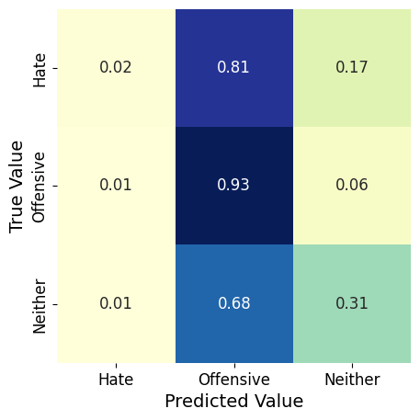

**Fig – 2.1 Confusion Matrix**

**Analysis Performance**

• The system utilizes a wide range confusion matrix while visualizing and analyzing its results. This approach would enable the following:

• - Analyzing the accurate performance by all the 4 models individually

• - Analyze the error based on data patterns

• - Opportunities for optimum improvement in the system

• - Machine Learning Model comparision.

**• Temporal Efficiency**

**Detection:** this model can identify the tweets on base of 3 categories weather it is hateful , offensive or neutral.

**Scalability:** It can handle a large volume of social media data as we are using SVM model which can perform better with larger data set.

**Resource Optimization:** Efficient use of computational resources to ensure faster analysis without overloading the system.

**Operational Efficiency:** Maintaining high detection accuracy while minimizing delays.

**Hate Speech vs. Offensive Language:** hate speech as language that expresses hatred towards a targeted group in a harmful or derogatory manner, while offensive language is broader and can include curse words and slurs without necessarily targeting specific groups with hateful intent.

**Data and Classification**: Using a crowd-sourced lexicon of hate speech and offensive terms, they collected a sample of tweets, which were manually labeled into three categories: hate speech, offensive but not hate speech, and neither. They trained a multi-class classifier to distinguish between these categories. The results showed that while tweets containing explicit slurs (like "ngger" or "fggot") are more likely to be classified as hate speech, others (like sexist language) are typically classified as offensive rather than hateful.

**Challenges in Classification**: The model showed that certain types of hate speech, especially less frequent ones (e.g., anti-Chinese hate), were misclassified more frequently. Tweets containing multiple slurs were often correctly labeled, but tweets that were borderline or lacked explicit hate speech terms were more challenging to categorize.

**Error Analysis**: Misclassifications often stem from the context or lack of strong keywords associated with hate speech. Tweets containing words like "btch" or "pssy" were labeled as offensive, but the model still struggled with cases where hate speech was implied rather than explicit.

**Future Directions**: future work should consider the social context in which hate speech occurs, and avoid over-relying on lexicons, as they may include terms that are offensive in some contexts but not necessarily hateful. They also suggest that better training data, with nuanced distinctions and greater

This study contributes to the challenge of making automated systems for detecting hate speech more precise by providing a more granular approach to classification and addressing the biases inherent in previous work.

**PROPOSED MODEL**

In order to carry out sentiment identification, every tweet was converted into lowercase letters and processed using the Porter Stemmer to remove any extra endings from the words. Feature generation was based on unigrams, bigrams, and trigrams, each with some weighting according to its TF-IDF score. Finally, to understand the sentences, we used NLTK to create unigrams, bigrams, and trigrams of Part-of-Speech (POS) tags.

The quality of the tweet was analyzed taking the Flesch-Kincaid Grade Level and Flesch Reading Ease scores with the number of sentences being set to one. The sentiment of the tweet was analyzed using a special social media sentiment dictionary (Hutto and Gilbert 2014) and a sentiment score was assigned to it.

Additionally, we added features like whether a tweet has hashtags, mentions, retweets, or URLs, and summarized with the counts of characters, words, and syllables in each tweet.

After this, we performed logistic regression with L1 penalties for culling irrelevant features from the features in the dataset. Then, we validated several models previously used by other researchers: logistic regression, naive Bayes, decision trees, random forests, and linear support vector machines (SVMs). Each single model was cross-validated using 5-fold cross-validation, with 10% of the data used for testing so that overfitting might be avoided. After experimenting with numerous classifiers and combinations of tuning parameters, we found the two highest-performing classifiers were logistic regressions and linear SVMs.

In our final**, we chose a logistic regression model with L2 penalty** since it allows us to interpret predicted probabilities for each class and has worked successfully in previous studies (Burnap and Williams 2015; Waseem and Hovy 2016). We fitted the final model on the complete dataset and used it to predict labels for tweets. One-vs-rest was employed, where each representation of itself.

**IMPLEMENTATION AND RESULTS**

**Preprocessor Files**

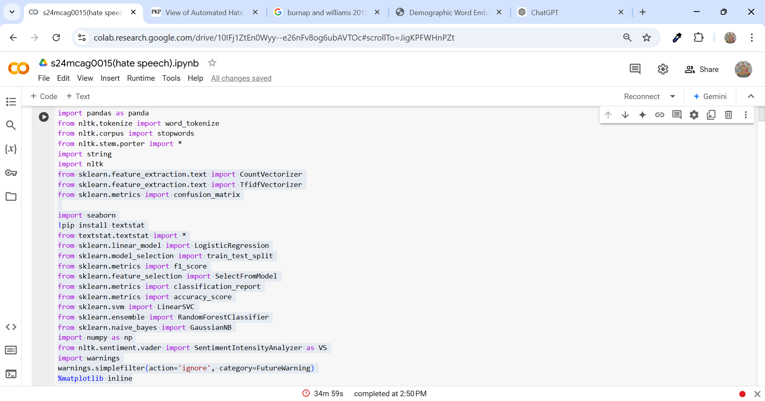

**Fig- 3.1 – Importing important files and packeges**

**Feature Extraction Techniques:**

We use Count_Vectorizer and Tfidf_Vectorizer to turn words in tweets into numbers so our models can understand them. Count_Vectorizer counts how often each word appears, while Tfidf_Vectorizer gives more weight to unique words that might be important. This helps the model find patterns in tweets, making it easier to label them as hate, offensive, or neutral.

**Text Complexity Analysis:**

The textstat tool helps us understand how complicated the text is by measuring things like how easy it is to read, word length, and sentence complexity. This can affect how tweets are classified.

**Classification Algorithms:**

We try out several different models to see which one works best for detecting hate or offensive language: Logistic Regression (good for basic text classification), LinearSVC (works well with many features), Random Forest (finds a variety of patterns), and Naive Bayes (good with simple word counting). Testing multiple models helps us choose the one that balances accuracy and speed.

**Model Evaluation:**

Measure how well the models performs using a some of key metrics: a confusion matrix (shows correct vs. incorrect predictions for each category), accuracy score (overall correctness), f1-score (balances accuracy in detecting each category), and a classification report (provides details for each class). Together, these measures help us understand each model's strengths and weaknesses.

**Sentiment Analysis with NLTK:**

We use a tool called VADER from NLTK to check the emotional tone of each tweet. This sentiment score helps add context, showing whether a tweet is neutral, hateful, or offensive.

**Feature Selection:**

The Select from Model tool helps pick only the most important features, improving the model's performance and reducing complexity.

Data Splitting and Warnings Management:

train_test_split divides the data into training and testing sets to check how well the model performs, and warnings.simplefilter removes unnecessary warnings so the output is clear and easy to read.

* **NLTK** – It is a very common and useful library in the field of Natural Language Processing.

It is very useful in text preprocessing.

1. **Tokenization** – The tweets are split in word by word forming token.
2. **Stopwords** – It remove stopwords like (is , am ,are) from the tweets before further processing.
3. **Stemming** – It helps removing the unwanted the letters from the word making it as base form. Like, “running” convert as “run”.

**Data Collection and Labelling:**

The researchers used a hate-speech lexicon from Hatebase.org, which labels specific words and phrases identified as hate speech; the researchers then used the Twitter API to query all tweets containing these terms. This resulted in tweets corresponding to 33,458 users providing a total of 85.4 million tweets. Out of these, they randomly selected 25,000 tweets that contained dictionary-referenced words and had them manually labelled by CrowdFlower workers. Each tweet was then classified into one of the following categories: hate speech, offensive but not hate speech, or neither. Workers were told to view the words' usage in context rather than at face value. A total of 24,802 tweets were labelled: 5% as hate speech, 76% as offensive, and 16.6% as non-offensive.

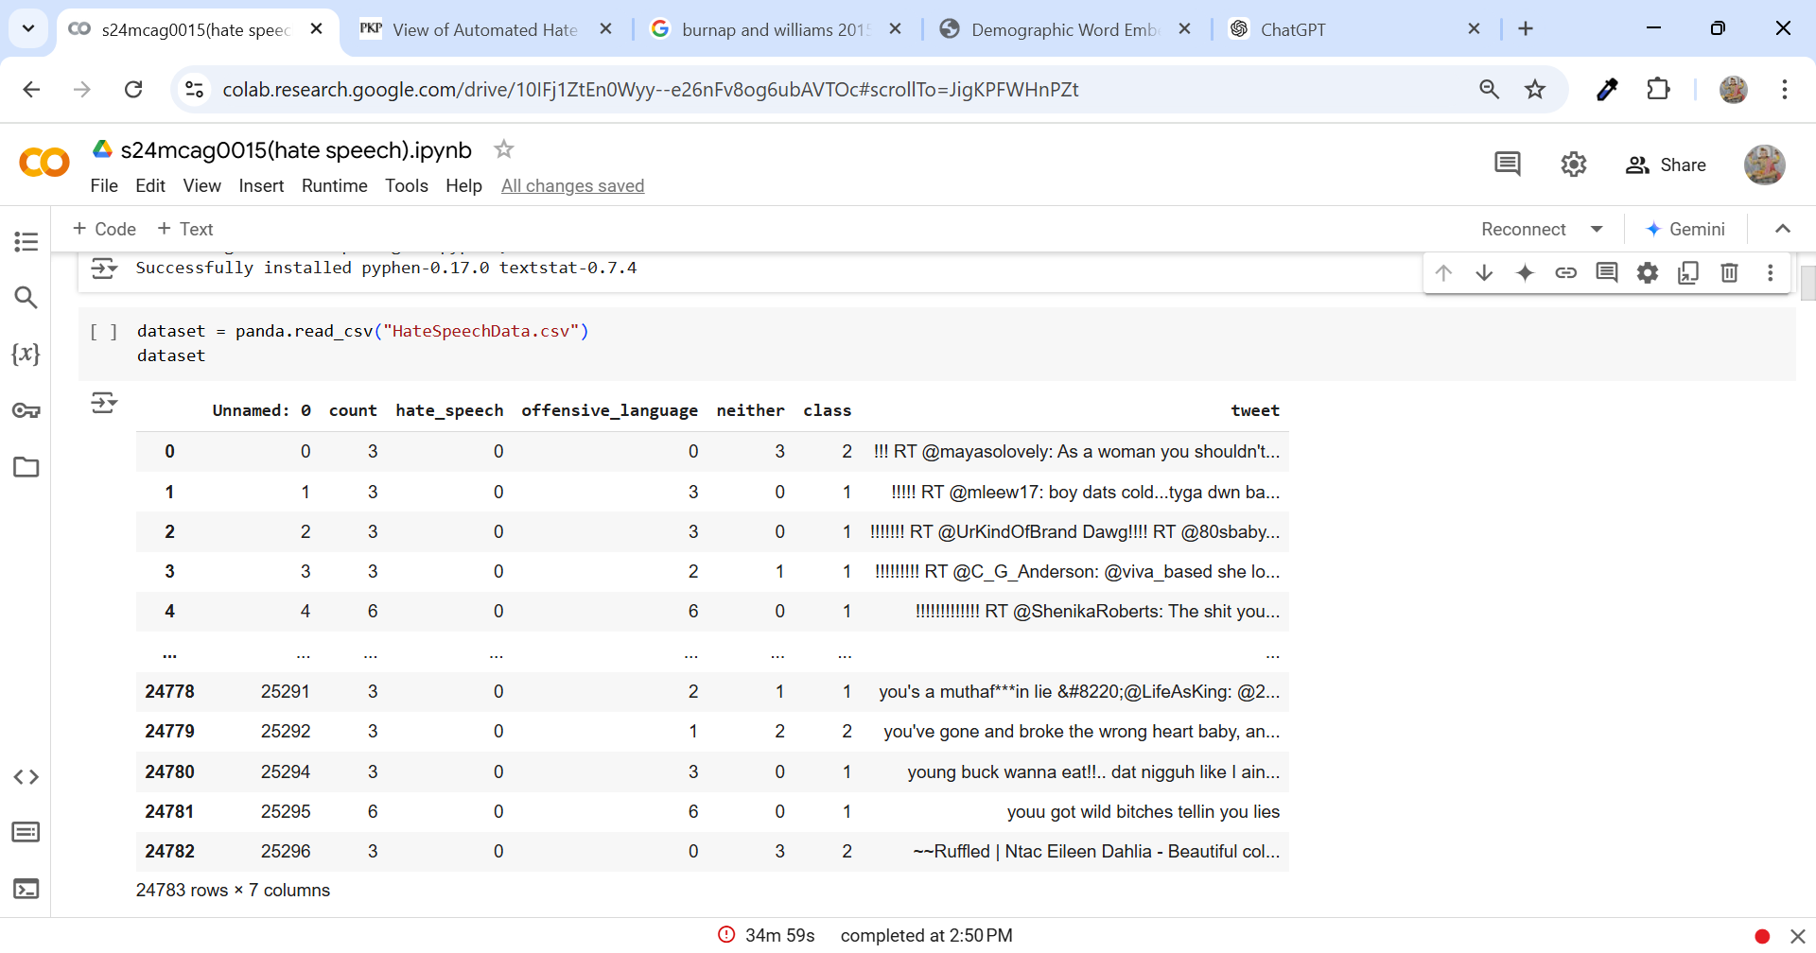

**Fig-3.2 – Labeling the data into 3 categories**

This dataset contains different columns that tell us about each tweet. The column called Unnamed: 0 is just an extra index, so we don't really need it. The count column shows how many times a tweet has been flagged. The hate_speech, offensive_language, and neither columns help us understand what kind of language the tweet has. They tell us if the tweet contains hate speech, offensive words, or neither. The class column gives the main label for each tweet:

* 0 means the tweet has hate speech,
* 1 means it has offensive language,
* 2 means it has neither.  
  The last column, tweet, shows the actual text of the tweet. This setup helps us use the tweet’s text to figure out its label, whether it's hate speech, offensive language, or neither.

**Data Visualization using Histogram**

**Code –**

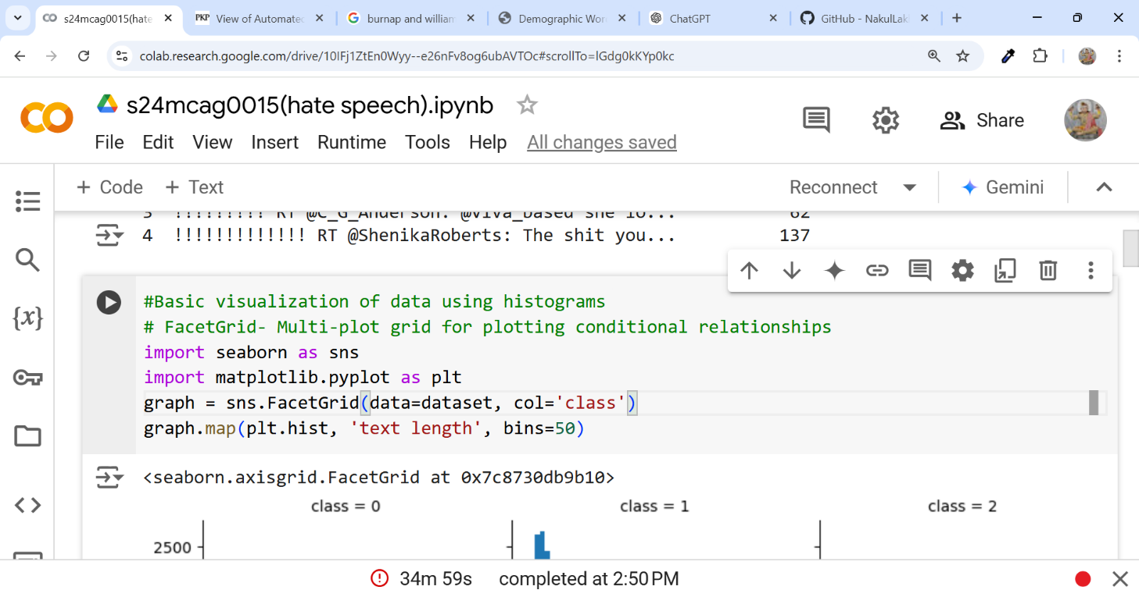

**Fig 3.3 – code for Data visualization**

**Output**

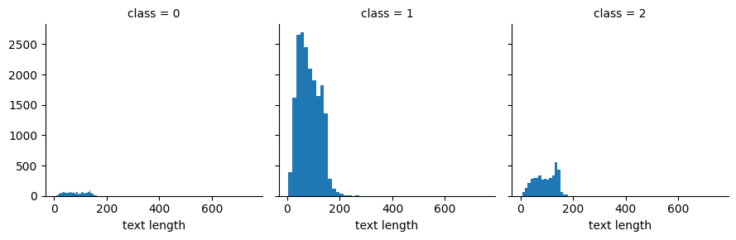

**Fig 3.4 – output of Data visualization Code**

We used FaceGrid Plotting and histogram to represent the length of the tweets, on the basis of their of their length we can observe the data pattern and the nature of the labeled tweets .In the above graph the x-axis shows the length of the tweets and the y-axis shows frequency(count) of twee falling in each categories.

**Box-Plot visualization**

**Code**

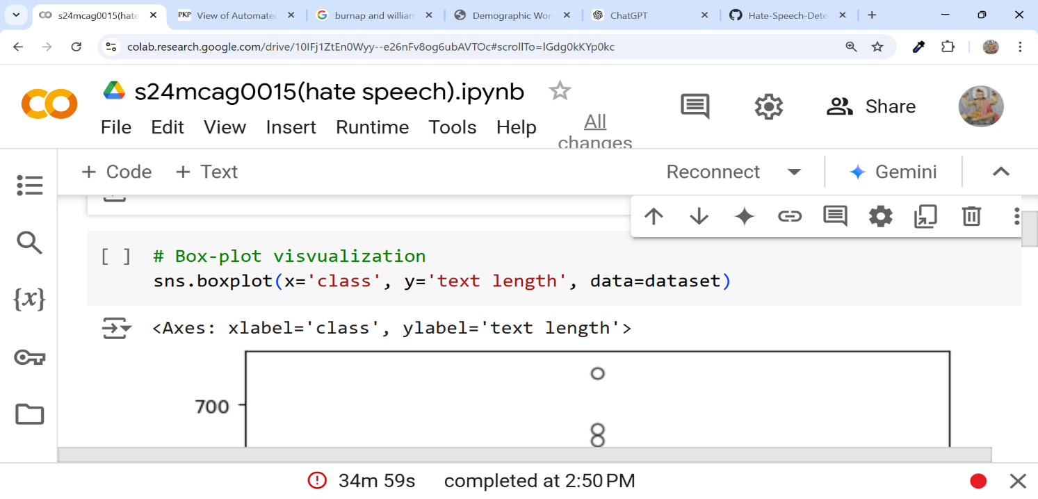

**Fig-3.5 – Code for Box-Plot**

**Output** 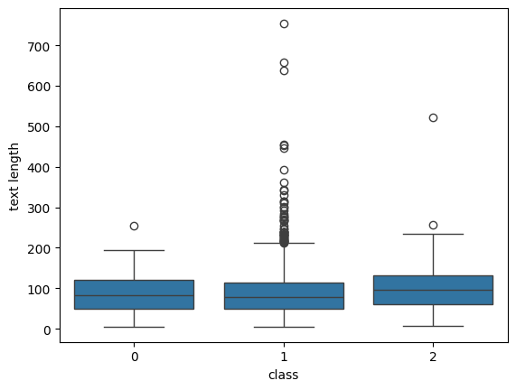

**Fig to see the length of tweets falling in each categories**

In this box plot, the x-axis represents the different tweet classes (like hate,offensive,neutral), and the y-axis represents the length of tweets, measured by the number of characters or words. Each box shows how tweet lengths vary within each class.

The box in each plot covers the middle 50% of tweet lengths, giving a clear view of the typical range for each class. A line inside the box shows the median length, or the central point of tweet length for that class. The lines (whiskers) extending out from the box show the general range, while any points outside the whiskers are unusually short or long tweets—these are called outliers. This layout helps us compare tweet lengths across the different classes easily.

**Labeling the tweet count**

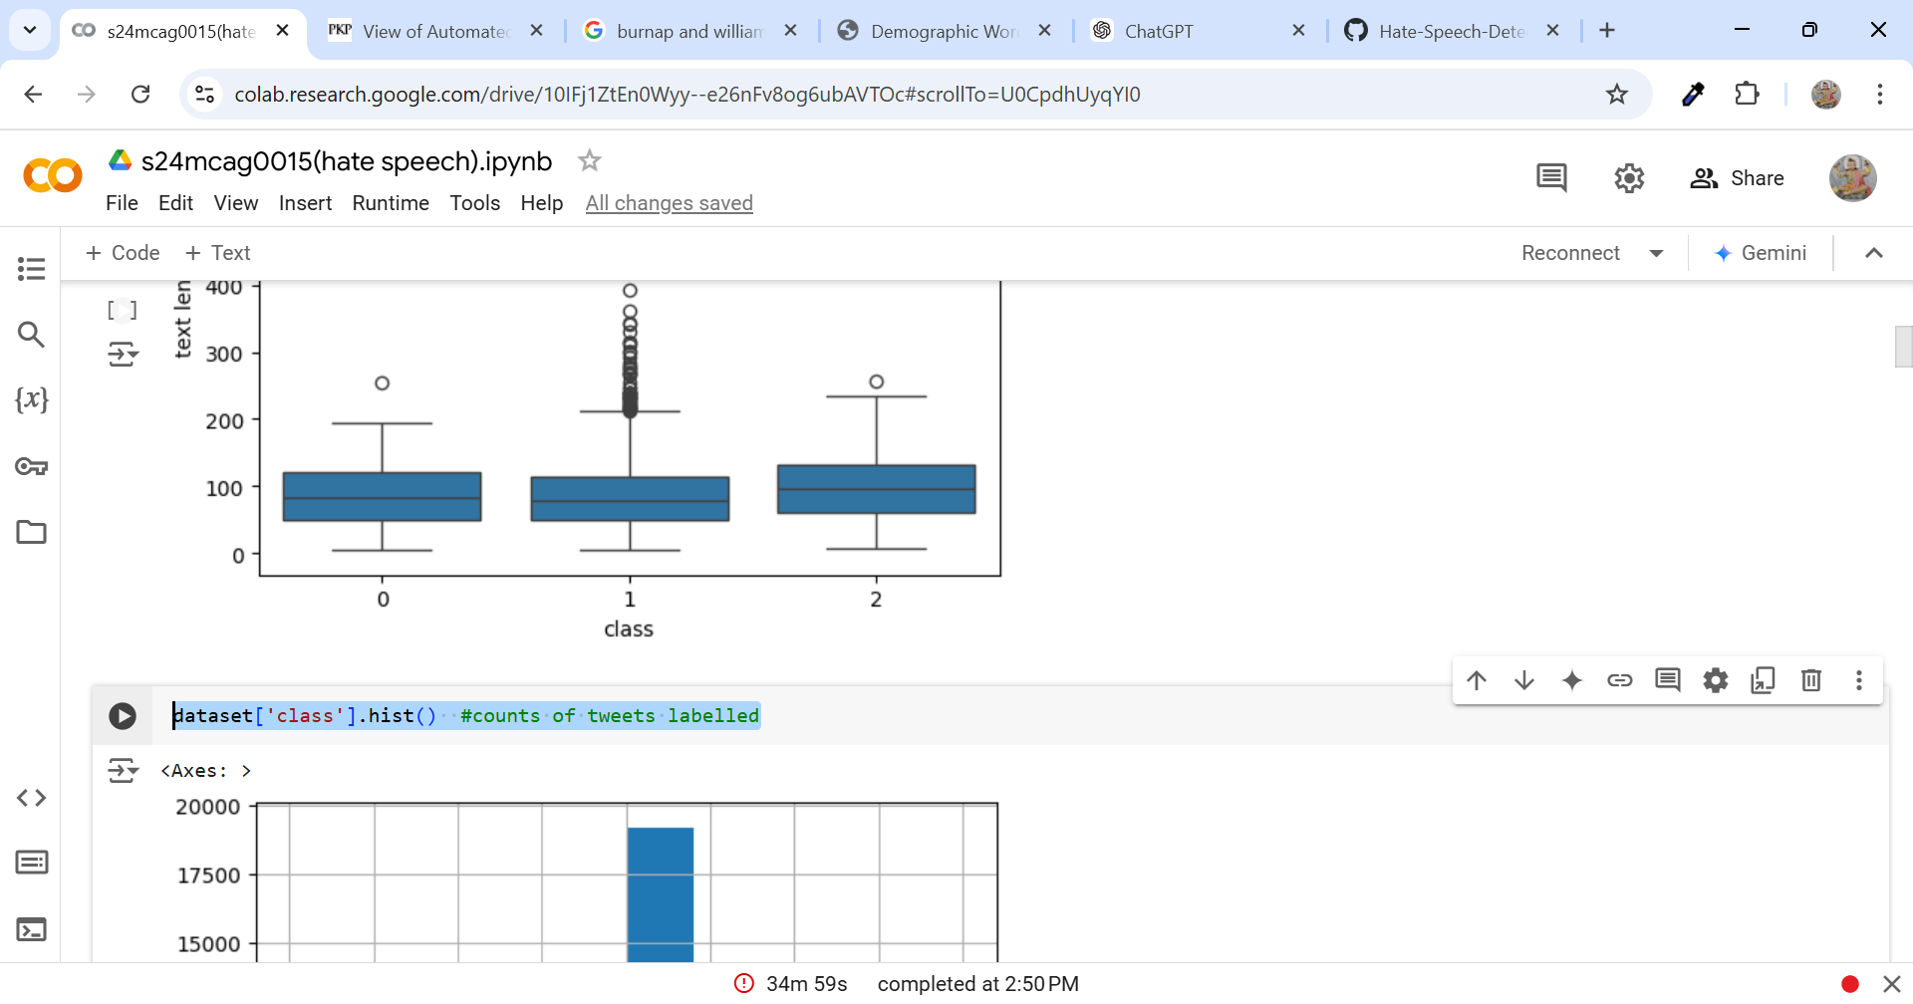

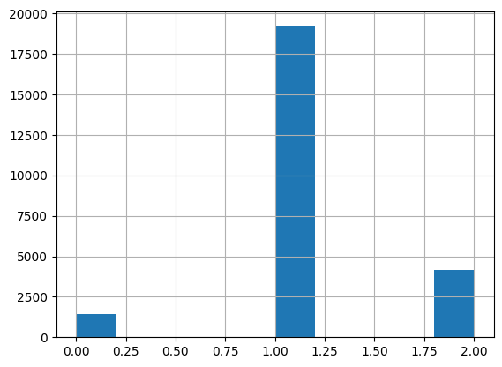

**Fig- 3 Histogram representing the count of tweets of each category**

We just converted the the Box-plot data in histogram on x-axis the 0,1,2 represent the the hate, offensive and neutral tweets respectively.

Y- axis represents the the word count of each category.

**PREPROCESSING OF TWEETS**

**Code**

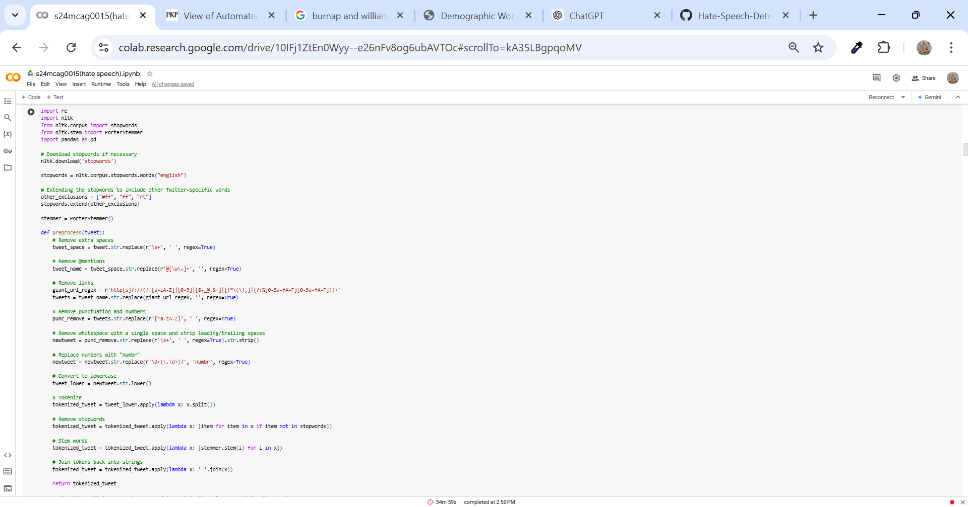

**Fig Code for tweet preprocessing in for of tokens**

The above line code removes any extra spaces in the tweets, then deletes mentions (like @username) to keep usernames out of the text. It also filters out any links since they’re usually unnecessary for analysis. Next, it takes out punctuation and numbers, replacing numbers with a placeholder word ("numbr").

After cleaning up any remaining spaces and making everything lowercase, the code splits each tweet into individual words. It then removes common words (like the and is) that don’t add much meaning. Each word is then reduced to its root form (so running becomes run) to group similar words together. Finally, it combines everything back into a single string for each tweet.

The cleaned tweets are added as a new column in the dataset, making it easy to compare with the original text and check the results.

**Output :-**

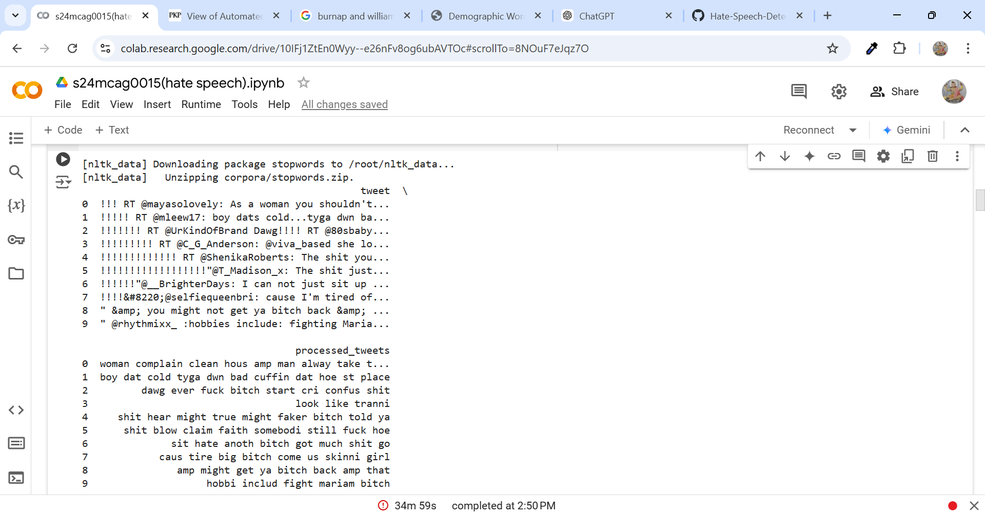

**Fig Result of Code**

**Visualization Of Most Common Words**

**Code – All the most Common Words in DataSet**

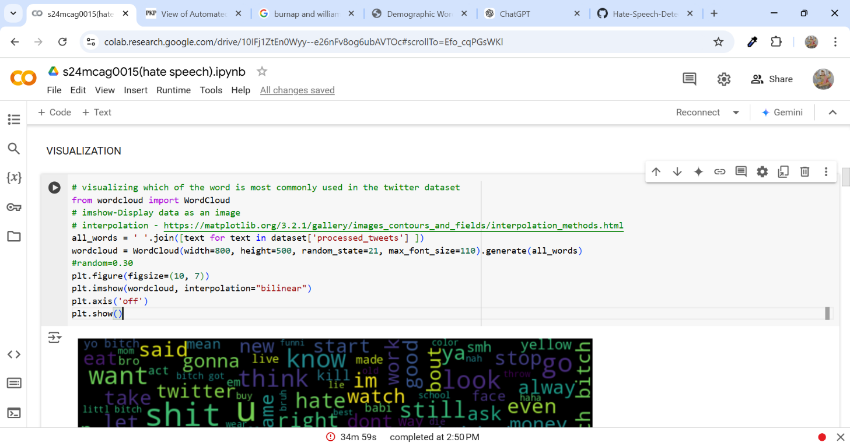

**Fig Most Common Word in datset**

This code is a word cloud, fun and great to look at; you see all the most common words in your tweets. Here's how it works:

It first collects all the tweets and forms them into one huge string of text. It then generates the word cloud where the size of each word depends upon how many times it comes up; the more it occurs the bigger it appears.

Finally, it outputs the word cloud itself with no extra information such as axes so you just focus on the words. The resultant visual high lights the most frequently used words in the dataset and can quickly identify themes or topics that are of importance within the tweets.

**Result :-**

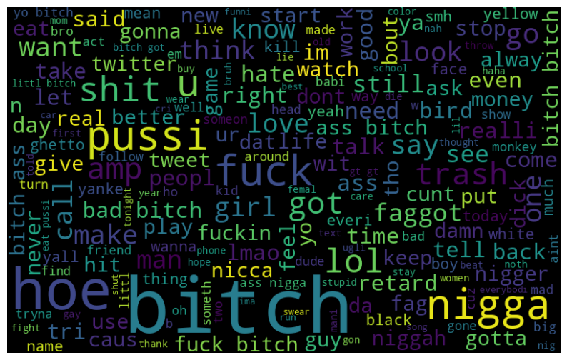

Fig – Output

**Most Common Hate Speech**

**Code:-**

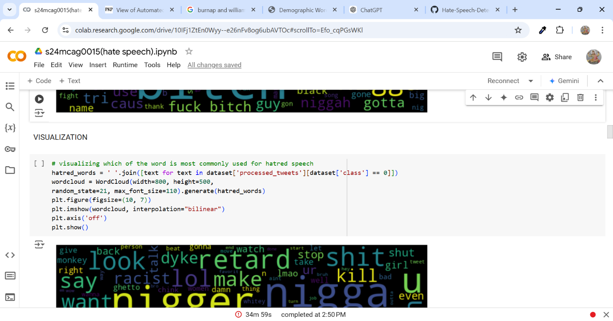

**Fig Code For Visualizing most common hatred words**

**Output :-**

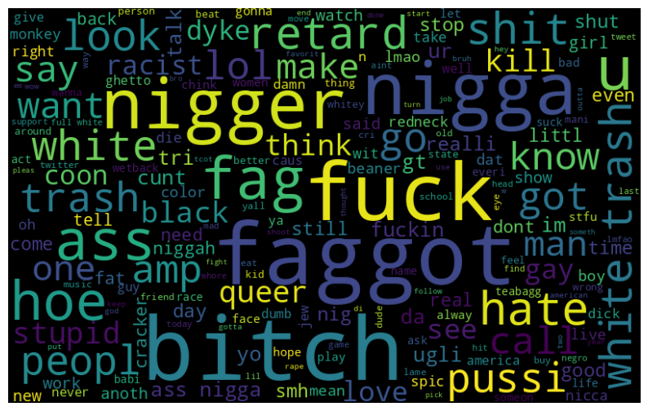

**Fig Most Common hatred Words**

**Most Common offensive words**

**Code:-**

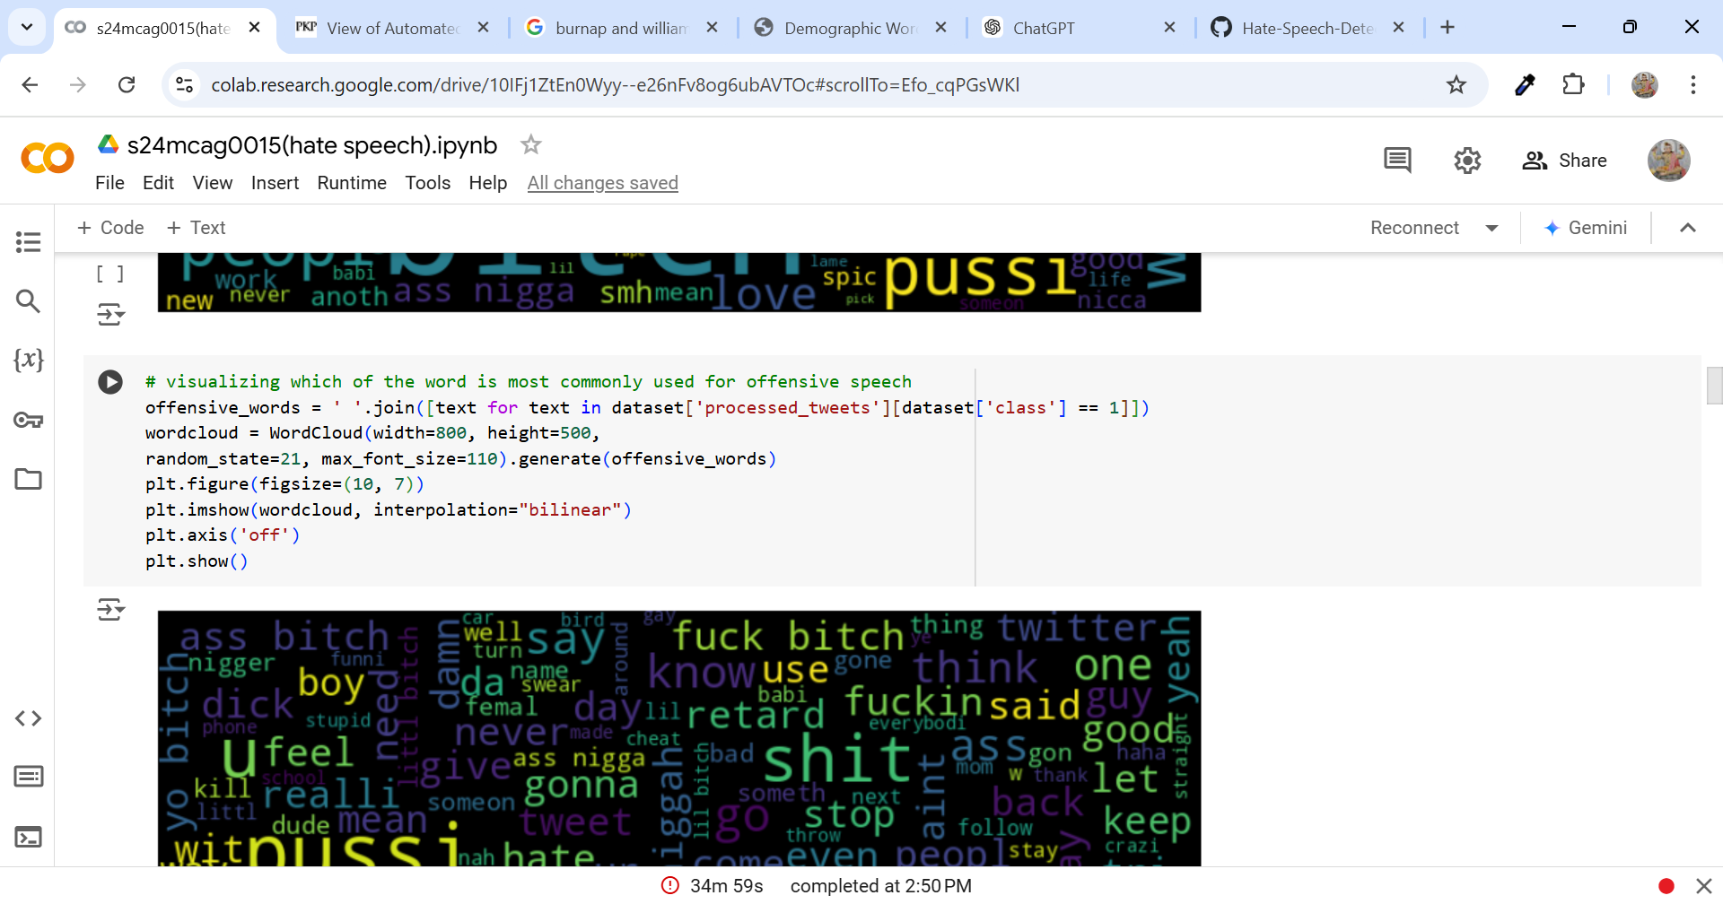

**Fig Code for most offensive speech**

**Output:-**

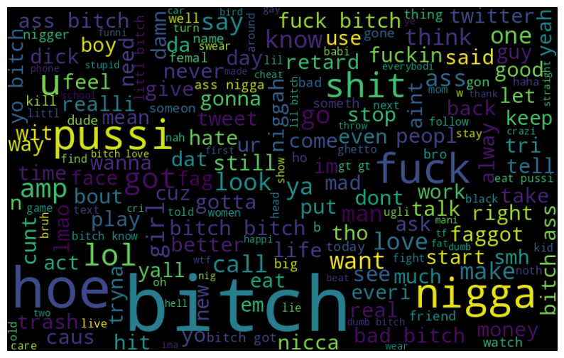

**Fig Most Common Offensive Words**

**Feature Extraction:**

For each tweet, they changed it into lower case and stemmed it with the help of the Porter stemmer. The features included unigrams, bigrams, and trigrams, each weighted by its TF-IDF score. POS tag features based on Penn tagger were provided to understand the structure of the sentences. Other features included readability scores such as the Flesch-Kincaid Grade Level and the Flesch Reading Ease, sentiment scores derived by a social media sentiment lexicon, and binary indicators for hashtags, mentions, retweets, and URLs.

**Running and Testing Various Models:**

* 1. **Logistic Regression**

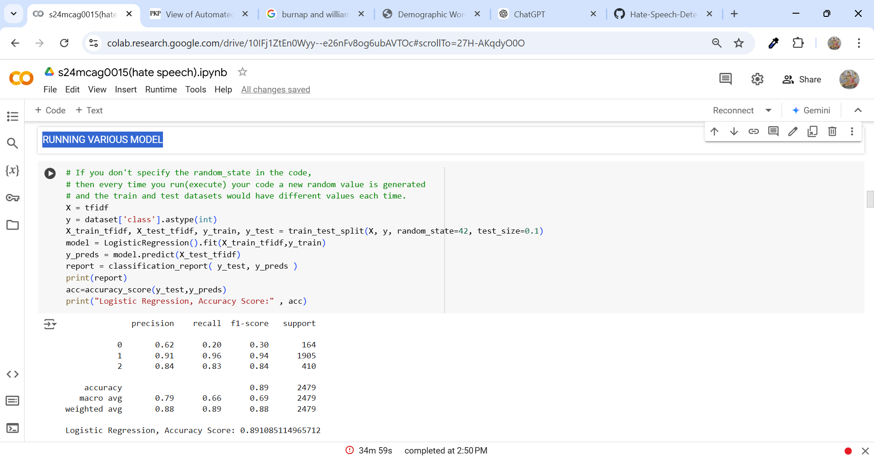

**Fig Accuracy Logistic Regression**

The **Logistic Regression** model does well overall, with an accuracy of 89%. It’s particularly good at identifying neutral tweets (96% recall), but struggles with offensive tweets (only 20% recall).

* **Precision**: It’s high for neutral (91%) and hate (84%) tweets, but lower for offensive tweets (62%).
* **Recall**: The model correctly identifies most neutra*l* tweets but misses many offensive ones.
* **F1-Score**: High for neutral (0.94) and hate (0.84), but low for offensive (0.30).

Overall, it performs best on neutra*l* tweets and has difficulty with offensive tweets.

**2.Random Forest Accuracy Score**

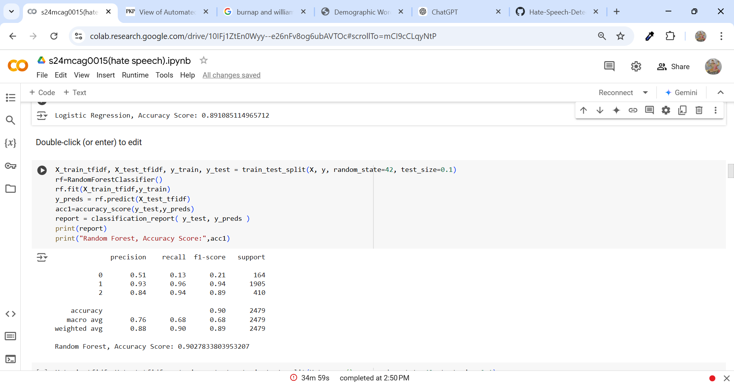

**Fig Accuracy Score Random Forest**

The model has an overall accuracy of 90%, which is quite good, but its performance varies across different categories. It struggles the most with hate speech, missing many hate tweets and having low precision and recall for this class. On the other hand, it performs excellently at identifying offensive tweets, with very high precision and recall. It also does a decent job with neutral tweets, maintaining a strong balance between precision and recall. In summary, the model is strong at detecting offensive and neutral tweets but has room for improvement when it comes to hate speech detection. To improve, you could try addressing the class imbalance by oversampling hate speech tweets or consider using a more advanced model like BERT for better results, particularly with hate speech.

**3.Naive Bayes Accuracy Score**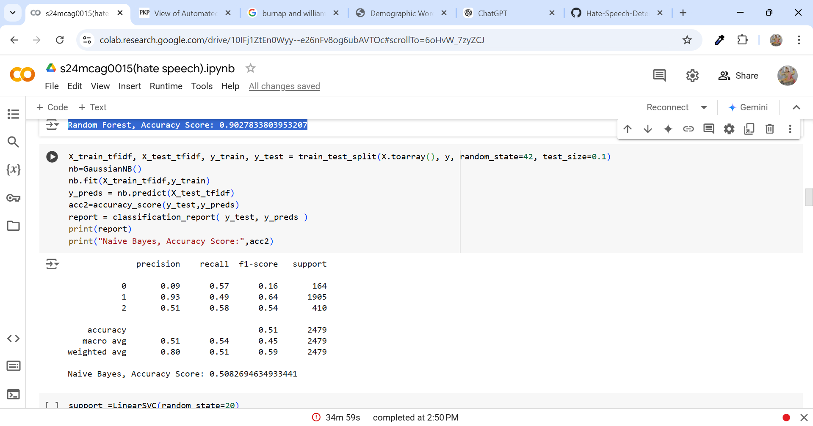

**Fig Accuracy Score of Naïve Bayes**

The **Naive Bayes** model shows mixed results across different classes. For *offensive* tweets, it has a very low precision of 9%, meaning it incorrectly labels most tweets as *offensive*. However, it performs better at recalling *offensive* tweets, identifying 57% of them. The model does well with *neutral* tweets, achieving high precision of 93%, but it misses about half of the actual *neutral* tweets, with a recall of 49%. For *hate* tweets, the model’s precision is 51%, so it correctly labels about half of the *hate* tweets, with a recall of 58%. Overall, the model has an accuracy of 51%, indicating it makes a lot of incorrect predictions. While it does best with *neutral* tweets, its performance is less reliable for *offensive* and *hate* tweets.

**SVM Accuracy Score**

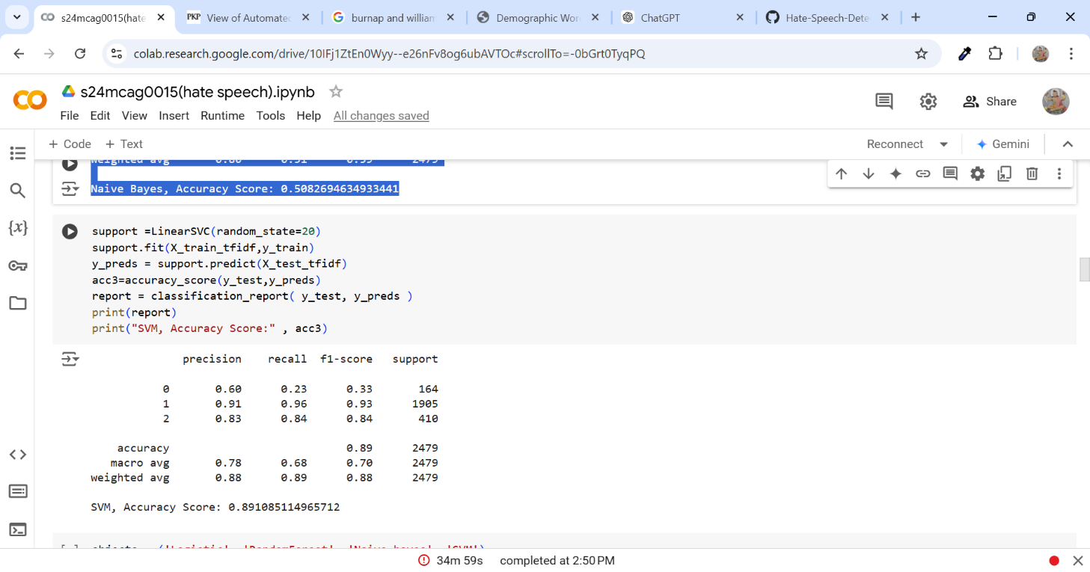

**Fig Accuracy of SVM**

The **SVM model** performs quite well overall, with an accuracy of 89%. It does especially well with *neutral* tweets, identifying most of them accurately with 91% precision and 96% recall. It also handles *hate* tweets fairly well, with 83% precision and 84% recall. However, the model struggles with *offensive* tweets, where it only correctly identifies 23% of them, despite having a precision of 60%. The model’s overall performance is decent across all classes, with the **macro average** showing a solid balance, and the **weighted average** highlighting strong results, particularly for *neutral* tweets. In short, the SVM model is effective for *neutral* and *hate* tweets but less reliable for *offensive* tweets.

**Overall Algorithm Comprasion for F1 Score**

**Code**

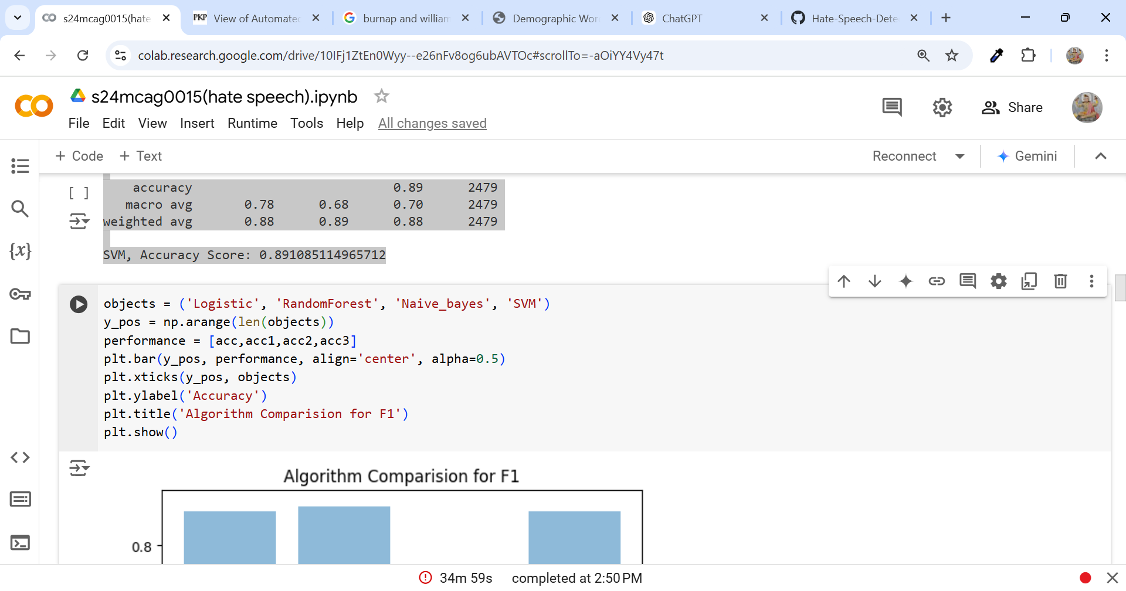

**Fig Code for Comprasion of F1 Score**

**Result**

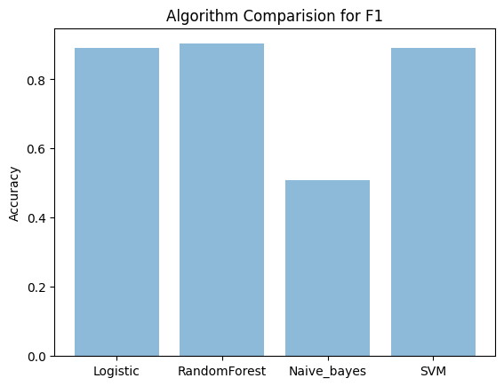

**Fig Alogorithm Comparision for F1**

The SVM model is the best overall for identifying tweets. It works really well with neutral tweets (scoring 0.94) and hate tweets (scoring 0.83), but it has trouble with offensive tweets, where it only scores about 0.33. Logistic Regression is also good for neutral and hate tweets (0.94 and 0.84), but like SVM, it struggles with offensive tweets (0.30). Naive Bayes doesn't perform well at all. It has very low scores for offensive tweets (0.16) and also struggles with neutral tweets (0.64).

So, SVM is the best model, especially for neutral and hate tweets. It does a lot better than Naive Bayes (about 0.30 better for neutral tweets). Although Logistic Regression is similar to SVM, SVM still has a slight edge for these types of tweets. If we want to find neutral or hate tweets, SVM is the most reliable.

**ADDING SENTIMENTAL ANALYSIS USING POLARITY FEATURE**

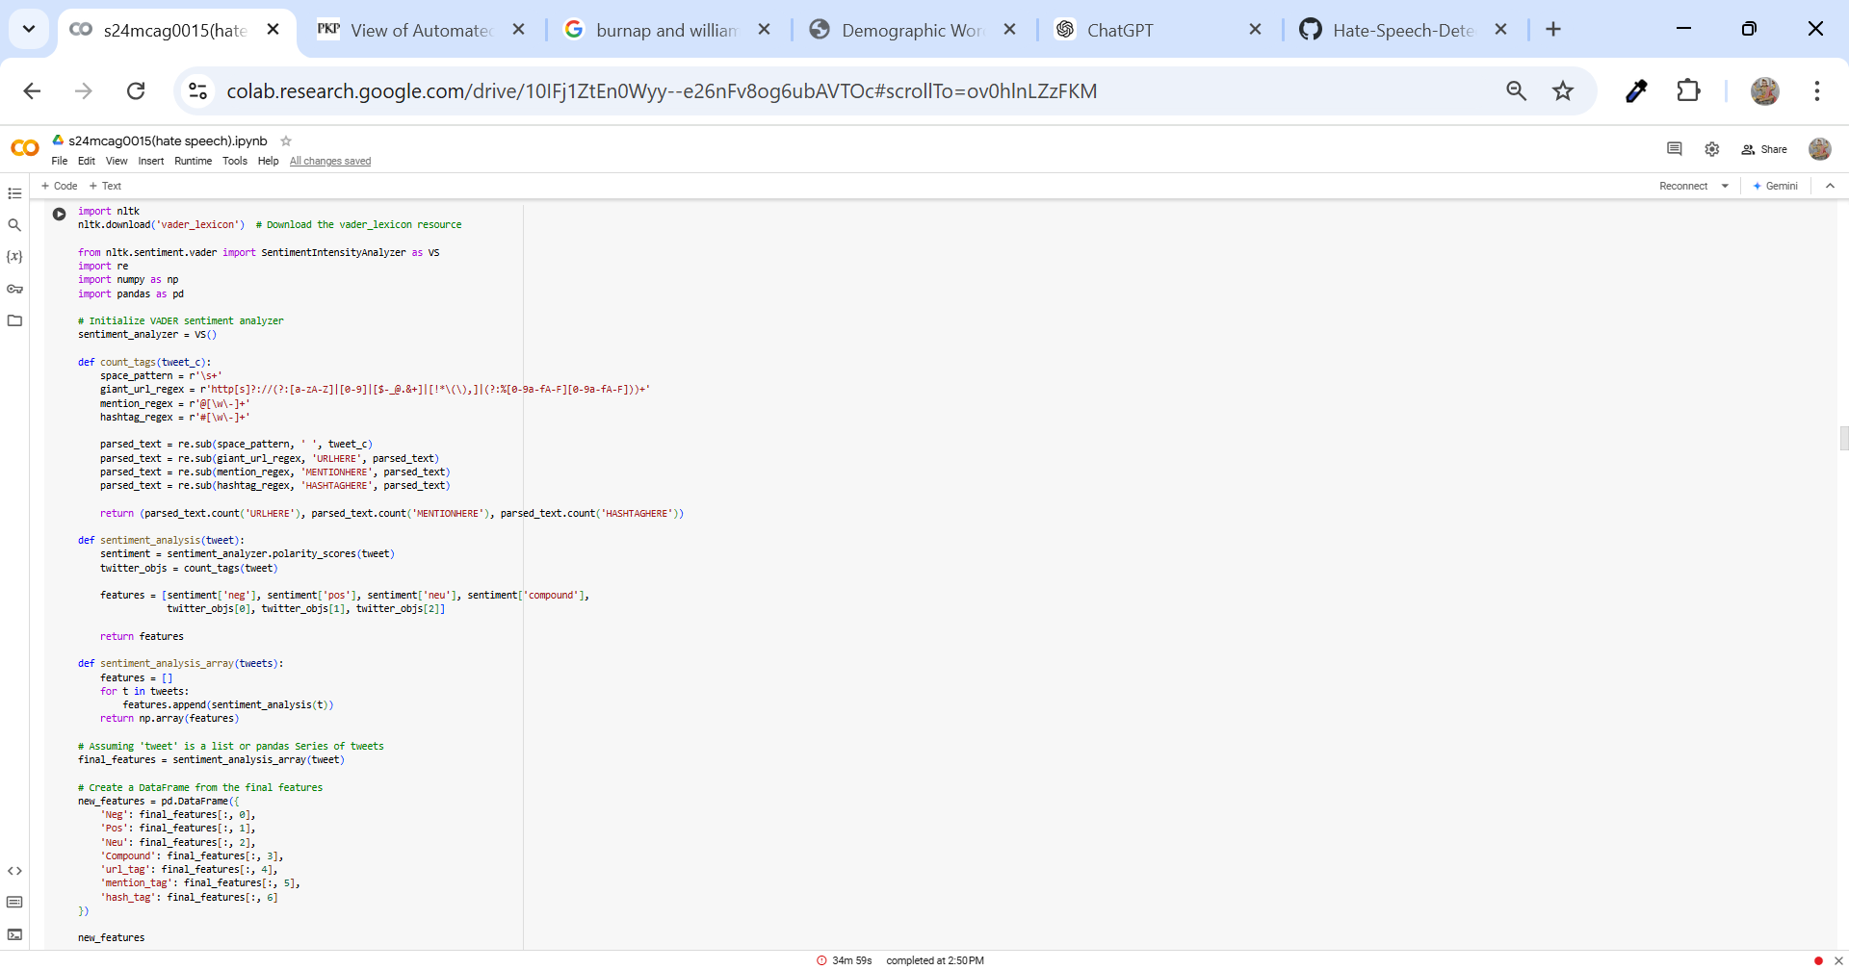

**Fig Code for Sentimental Analysis Using polarity feature**

It scans tweets and does only two big things: it checks the emotional tone of the view on every tweet and counts some parts of every tweet: links, mentions, and hashtags.

First, it uses something called VADER, which is a measure that determines if a given tweet is positive, negative, neutral, or a mix of those. It assigns each tweet four scores: how negative, positive, and neutral it is, and a final "compound" score that sums everything up into one number.

Then the code counts how many links (URLs), mentions (like @someone), and hashtags (like #topic) are in the tweet. The code replaces these with special placeholders like "URLHERE" to count more easily.

In summary, all of that data — sentiment scores and counts of the links, mentions, and hashtags — we put all of that together into a list for every tweet. These lists are grouped together in a table we know as a DataFrame, from which we can easily view the data about sentiment and count for each tweet.

**Running the models Using TFIDF with additional features**

**SENTIMENTAL ANALYSIS USING POLARITY FEATURE**

**1 Logistic Regression Accuracy Score**

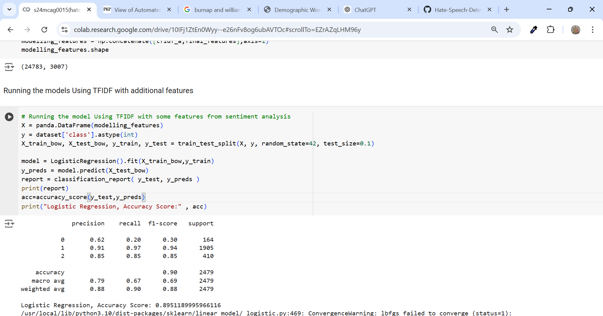

**Fig Code and Output for Logistic Regression Accuracy Score**

The Logistic Regression model does a solid job overall, especially when identifying neutral tweets, where it performs very well with both recall and F1-score. However, it has more difficulty with offensive tweets, as it misses a lot of them (low recall). The model is decent at recognizing hate speech tweets but could still improve. With an accuracy of 89.5%, it shows strong performance, though there's definitely room for improvement, particularly in accurately detecting offensive tweets.

**2 Random Forest Accuracy Score**

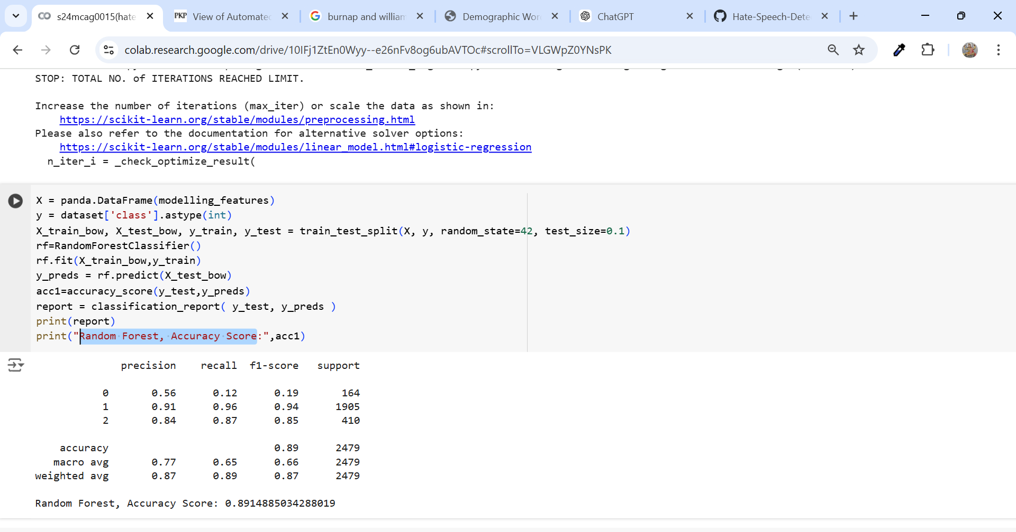

**Fig Code and Output for Random Forest Accuracy Score**

The Random Forest model performs decently, with an accuracy of 89.1%. It does a great job identifying neutral and hate speech tweets, with strong precision and recall for both classes. However, when it comes to offensive tweets, the model struggles. It misses a lot of offensive tweets, as shown by its very low recall of just 12%. The precision for offensive tweets is also only 56%, meaning it's not very good at correctly identifying them. The F1-score reflects this too, with a high score for neutral (0.94) and hate (0.85) tweets, but a low score for offensive tweets (0.19). So, while it works well for neutral and hate tweets, it needs improvement in detecting offensive content.

**Naive Bayes Accuracy Score:**

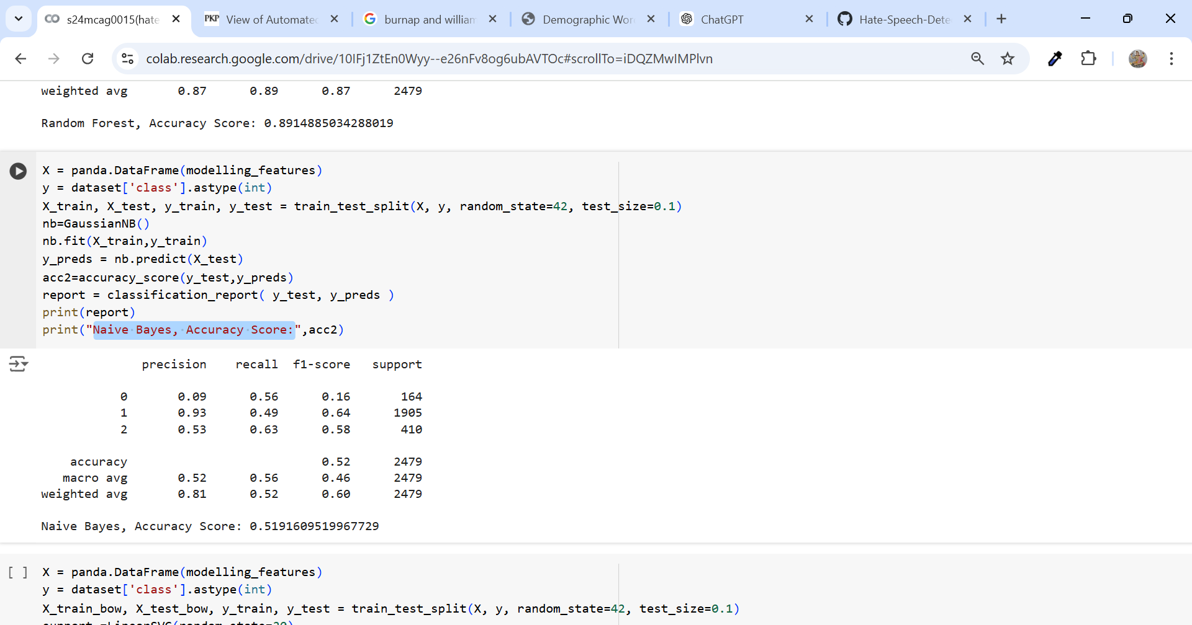

**Fig Code and Output for Naïve Bayes Accuracy Score**

The Naive Bayes model has an overall accuracy of 52%, meaning it correctly classifies a little more than half of the tweets. It’s good at identifying neutral tweets, with a high precision of 93%, but it struggles a lot with offensive tweets, where it has very low precision (only 9%). For hate speech, it does somewhat better with a precision of 53%. The model also misses a lot of offensive tweets, with a recall of just 56%, but it’s better at catching hate speech tweets (63%) and neutral ones (49%). The F1-score shows that the model performs best with neutral tweets (64%) but poorly with offensive tweets (16%) and does okay with hate speech (58%). So, while the Naive Bayes model works well with neutral tweets, it needs improvement in recognizing offensive and hate speech tweets more accurately.

**SVM, Accuracy Score**

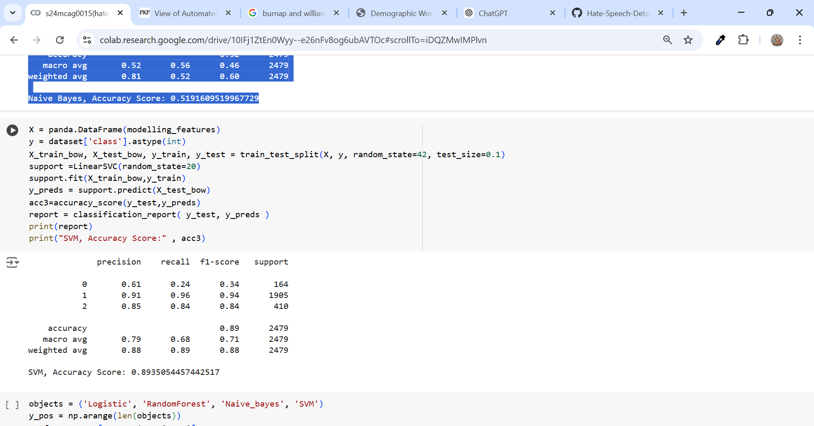

**Fig Code and Output for SVM Accuracy Score**

The SVM model showed a very excellent accuracy at 89.35%, and it performed well on neutral as well as hate speech tweets; it recalled 91% of neutral tweets with a high recall of 96%, and 85% hate speech tweets with a recall of 84% and thus F1-scores of 0.94 and 0.84, respectively. However, in the case of offensive tweets, it fails to detect 61% accuracy and commits a 76% false negative and with a recall of 24%, and F1 score at 0.34. As a whole, it scores best in the SVM model on neutral and hate speech but in finding offensive needs to improve.

**Algorithm ComparisonF2 ('Logistic', 'Random Forest', 'naïve bayes', 'SVM')**

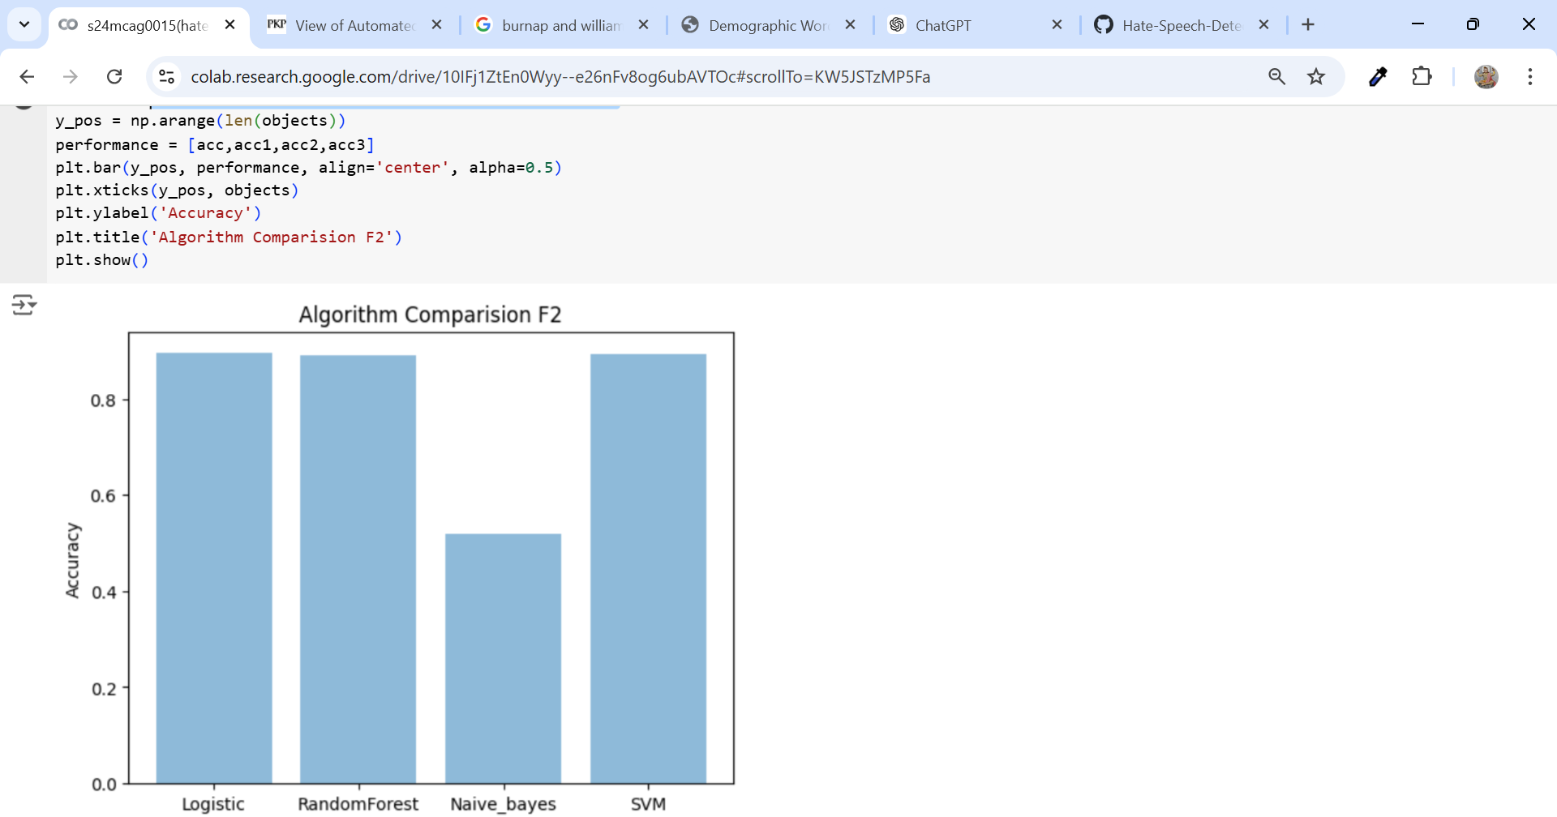

**Fig Algorithm comparison F2 ('Logistic', 'Random Forest', 'naïve bayes', 'SVM')**

When looking at the F2 score, which focuses more on how well the model identifies positive examples (through recall), SVM comes out on top. The SVM model performs particularly well at detecting neutral and hate speech tweets, with recall scores of 96% and 84%, respectively. This means it catches most of the relevant tweets in those categories, leading to a higher F2 score, even though it struggles with offensive tweets.

Logistic Regression also does well overall, but it has a bit more difficulty when it comes to identifying offensive tweets, which lowers its recall and F2 score. Random Forest has similar performance to Logistic Regression, but it performs worse on offensive tweets, which also brings its F2 score down a bit.

Naive Bayes falls behind, particularly when it comes to identifying offensive tweets, and this results in a much lower F2 score.

In the end, SVM is the best performer for F2 due to its strong recall for neutral and hate speech tweets. While it’s not as good with offensive tweets, its overall strong performance in other areas gives it the highest F2 score.

**Using TFIDF with sentiment scores, doc2vec and enhanced features**

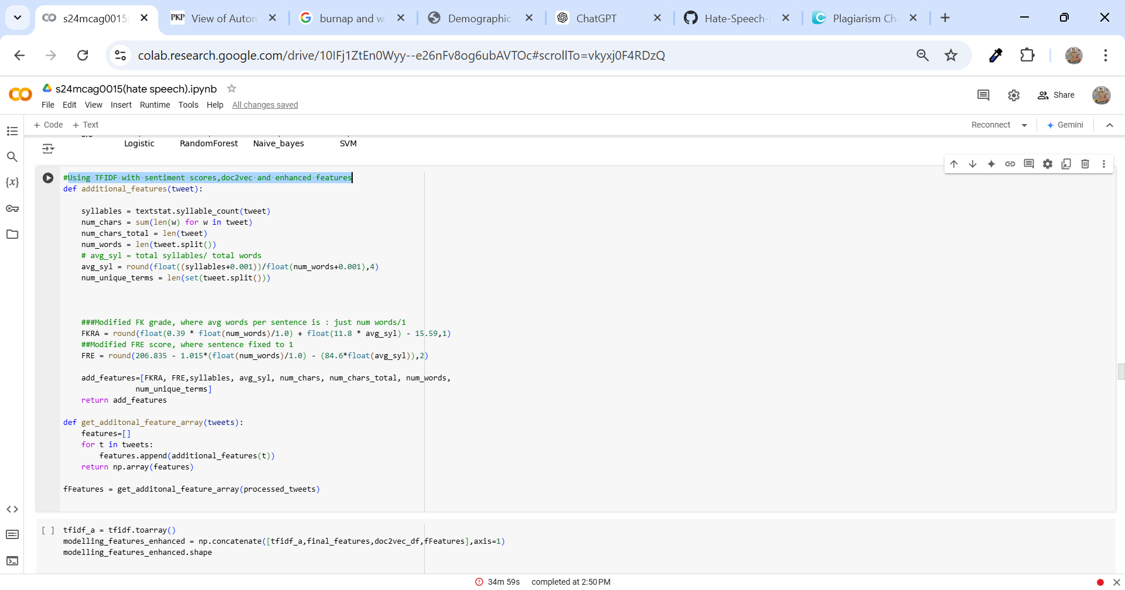

**Fig Code TFIDF with sentiment scores, doc2vec and enhanced features**

The code is designed to enhance tweet analysis by extracting additional features that can improve machine learning predictions.

First, the additional features function calculates various readability metrics, such as syllable count, word count, and two popular readability scores (Flesch-Kincaid and Flesch Reading Ease). It also tracks the number of unique terms and characters in a tweet. These features help capture how complex or easy to read a tweet might be.

The get additonal feature array function takes a list of tweets and applies the additional_features function to each one, returning an array of these calculated features.

Finally, all the features—TF-IDF values (which measure word importance), sentiment analysis scores, Doc2Vec embeddings (for semantic meaning), and the readability features—are combined into a single dataset. This enriched feature set is used to train a machine learning model, making it more powerful in predicting tweet categories like offensive, neutral, or hate speech.

**Running the model Using TFIDF with enhanced features with sentiment scores,doc2vec and enhanced features**

**Logistic Regression, Accuracy Score:**

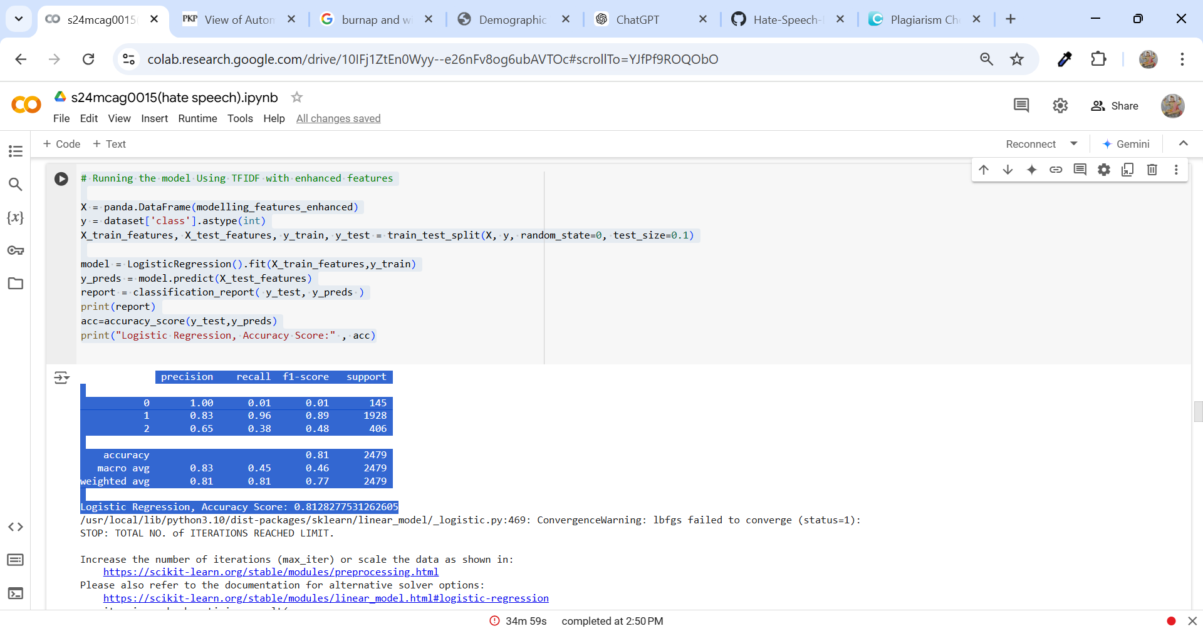

**Fig Logistic Regression, Accuracy Score:**

The model, which combines TF-IDF and additional features, achieved 81% accuracy in classifying tweets. It’s very good at recognizing neutral tweets, where it shows high precision and recall. However, it has trouble with offensive tweets, as it identifies very few of them correctly. For hate tweets, it does a decent job, but there's still room for improvement. Overall, it’s reliable for neutral tweets but could be better at detecting offensive and hate speech.

**Confusion Matrix for TFIDF with additional features**

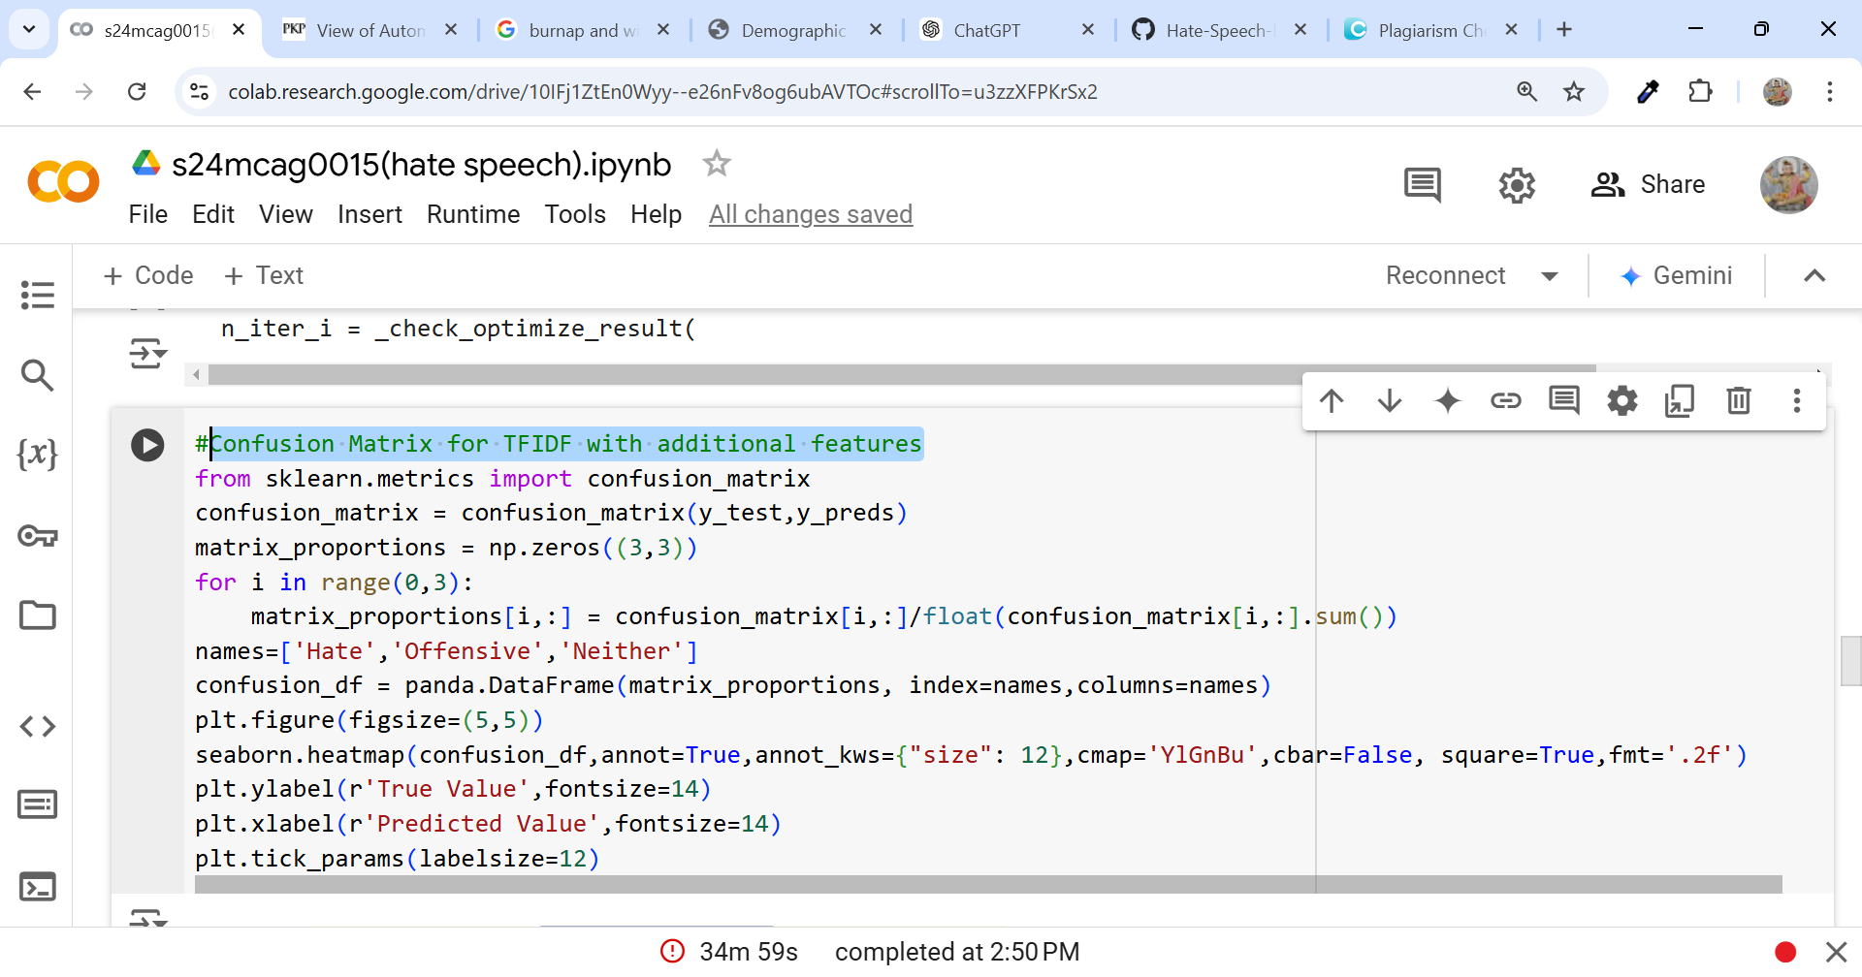

**Fig Code for Confusion Matrix for TFIDF with additional features**

**Output**

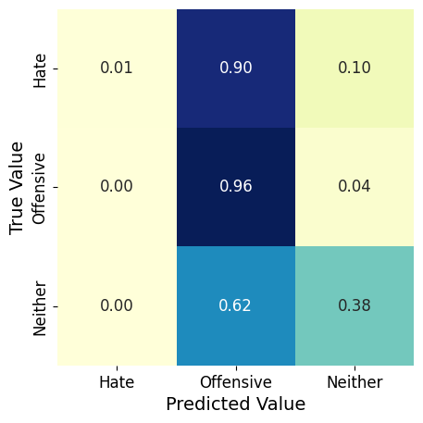

**Fig Output of Confusion Matrix for TFIDF with additional features**

From the confusion matrix its clear that the model misclassifies 78% of the hate data as offensive data. This explains the reduction in class-0

**Bar on the histogram for the predicted class and increase of bar for class-1 (offensive).**

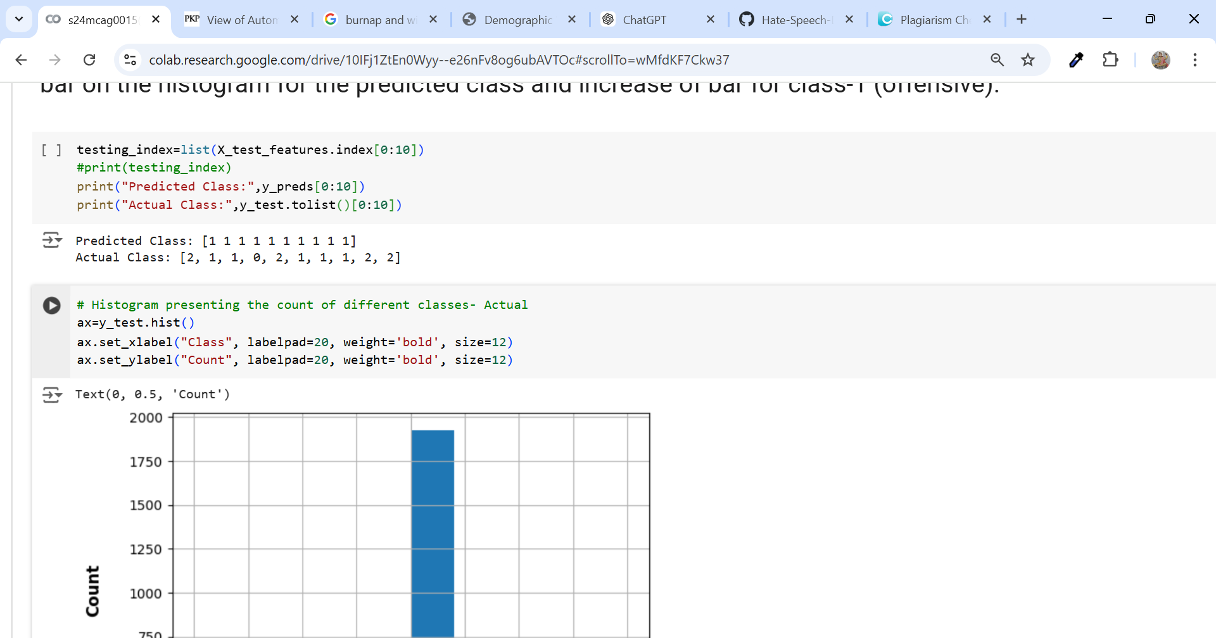

**Fig presenting the count of different classes**

**Output:-**



**Fig presenting the tweet class and their word count**

This code checks how well the model is performing by comparing the predicted classes to the actual classes for the first 10 tweets in the test set. It prints both the predicted and actual classes so we can easily see where the model got it right and where it didn’t. Additionally, it creates a histogram showing the number of tweets in each class (neutral, hate, or offensive), which gives a visual overview of the class distribution in the test data. This helps in understanding both how balanced the data is and how well the model might handle each class.

**Running the models Using TFIDF with additional features from sentiment analysis and doc2vec**

**SVM, Accuracy Score**

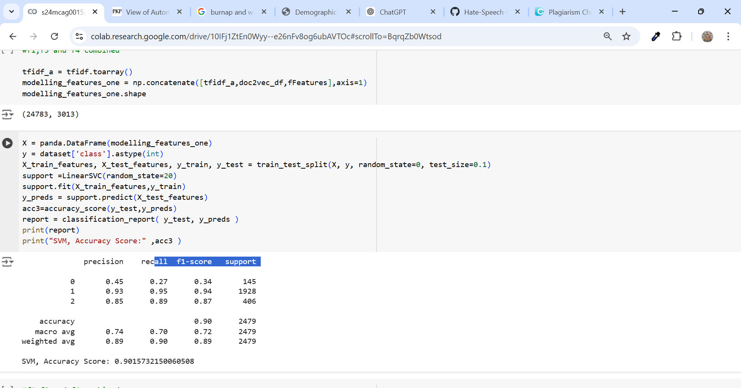

**Fig SVM, Accuracy Score**

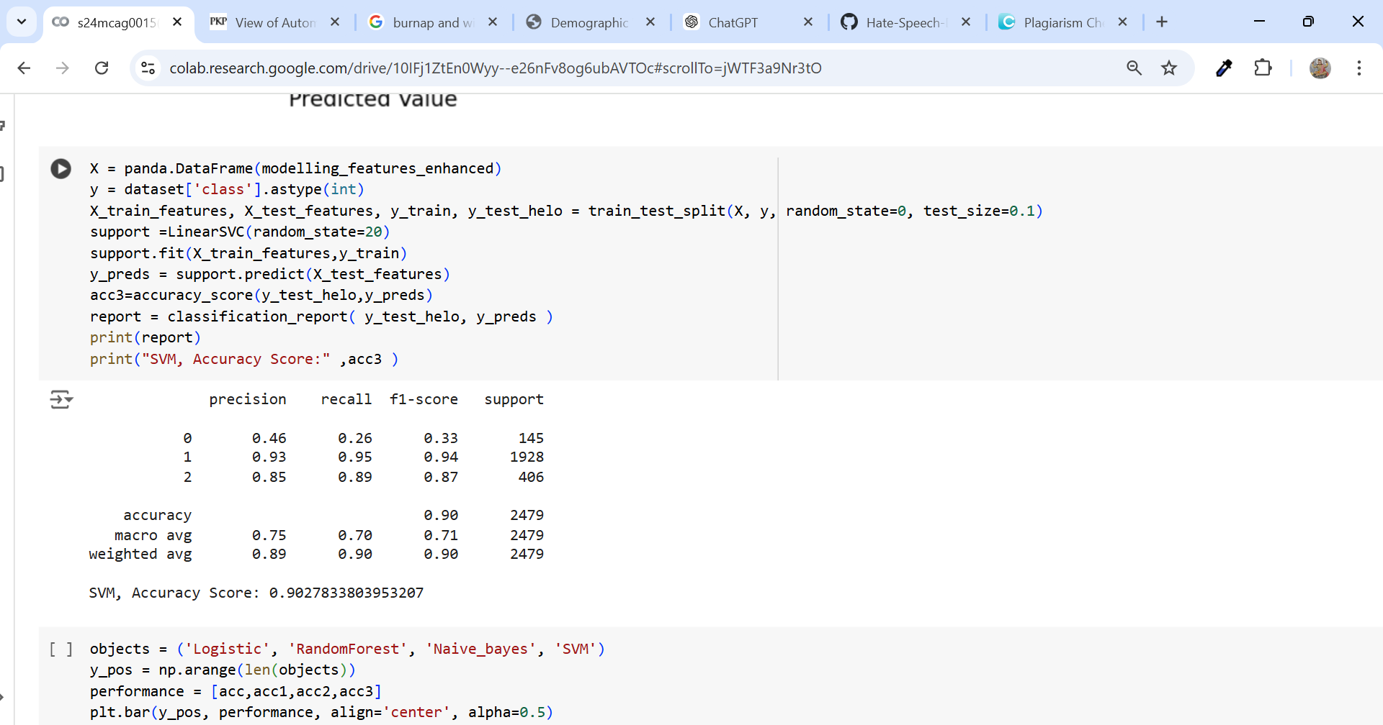

**Fig SVM, Accuracy Score**

The SVM model using TF-IDF with extra features is doing quite well overall, with an accuracy of 90%. It’s especially accurate at spotting neutral tweets, correctly identifying most of them with high precision and recall. For hate tweets, it also performs strongly, showing good accuracy in both precision and recall. However, the model finds it tougher to accurately identify offensive tweets, catching only around a quarter of them correctly. Overall, this model is great for identifying neutral and hate tweets but has some challenges when it comes to spotting offensive tweets.

**Algorithm Comparison Score with additional features**

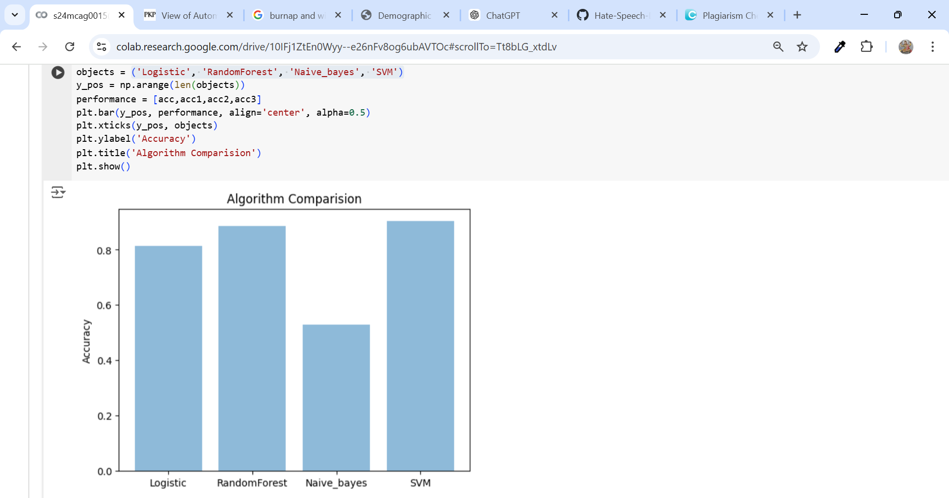

**Fig Algorithm comparison ('Logistic', 'Random Forest', 'naïve bayes', 'SVM')**

The SVM model does a good job of identifying neutral tweets, scoring high on both precision (93%) and recall (95%). This means that the model can recognize most neutral tweets correctly without much mix-up. For hate tweets, it also performs fairly well, with an 85% precision and an 89% recall, showing it can accurately identify most of these tweets too.

**User Input And Result**

**Function predicting the result**

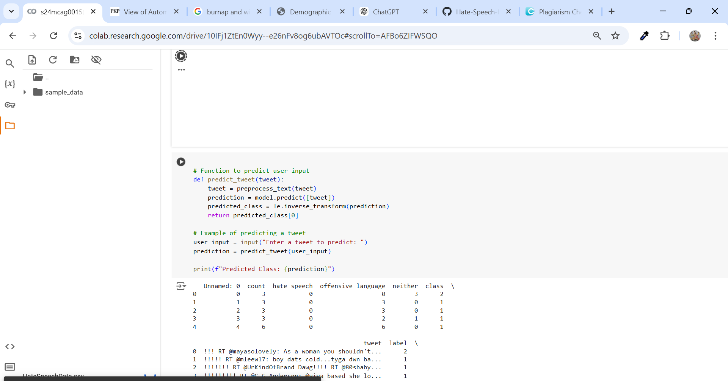

**Fig Showing the function for user input and result prediction**

**Result for different categories tweets**

**Case-1 Hate Speech –** class 0

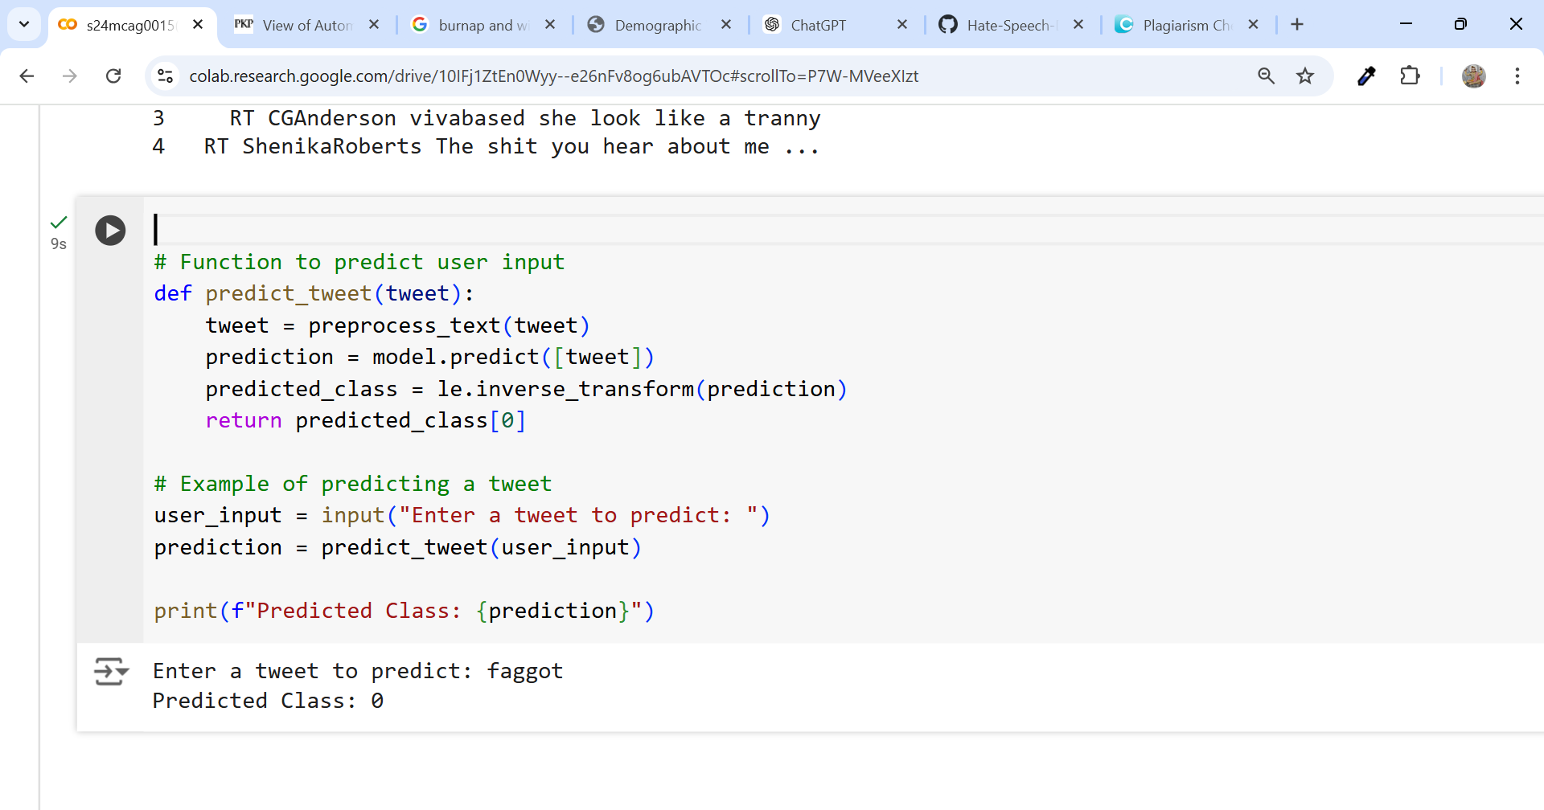

**Fig predicting result for Hatred speech**

**User input –** faggot

**Predicted class –** 0 (Hate speech)

**Case-2 Offensive language –** class 1

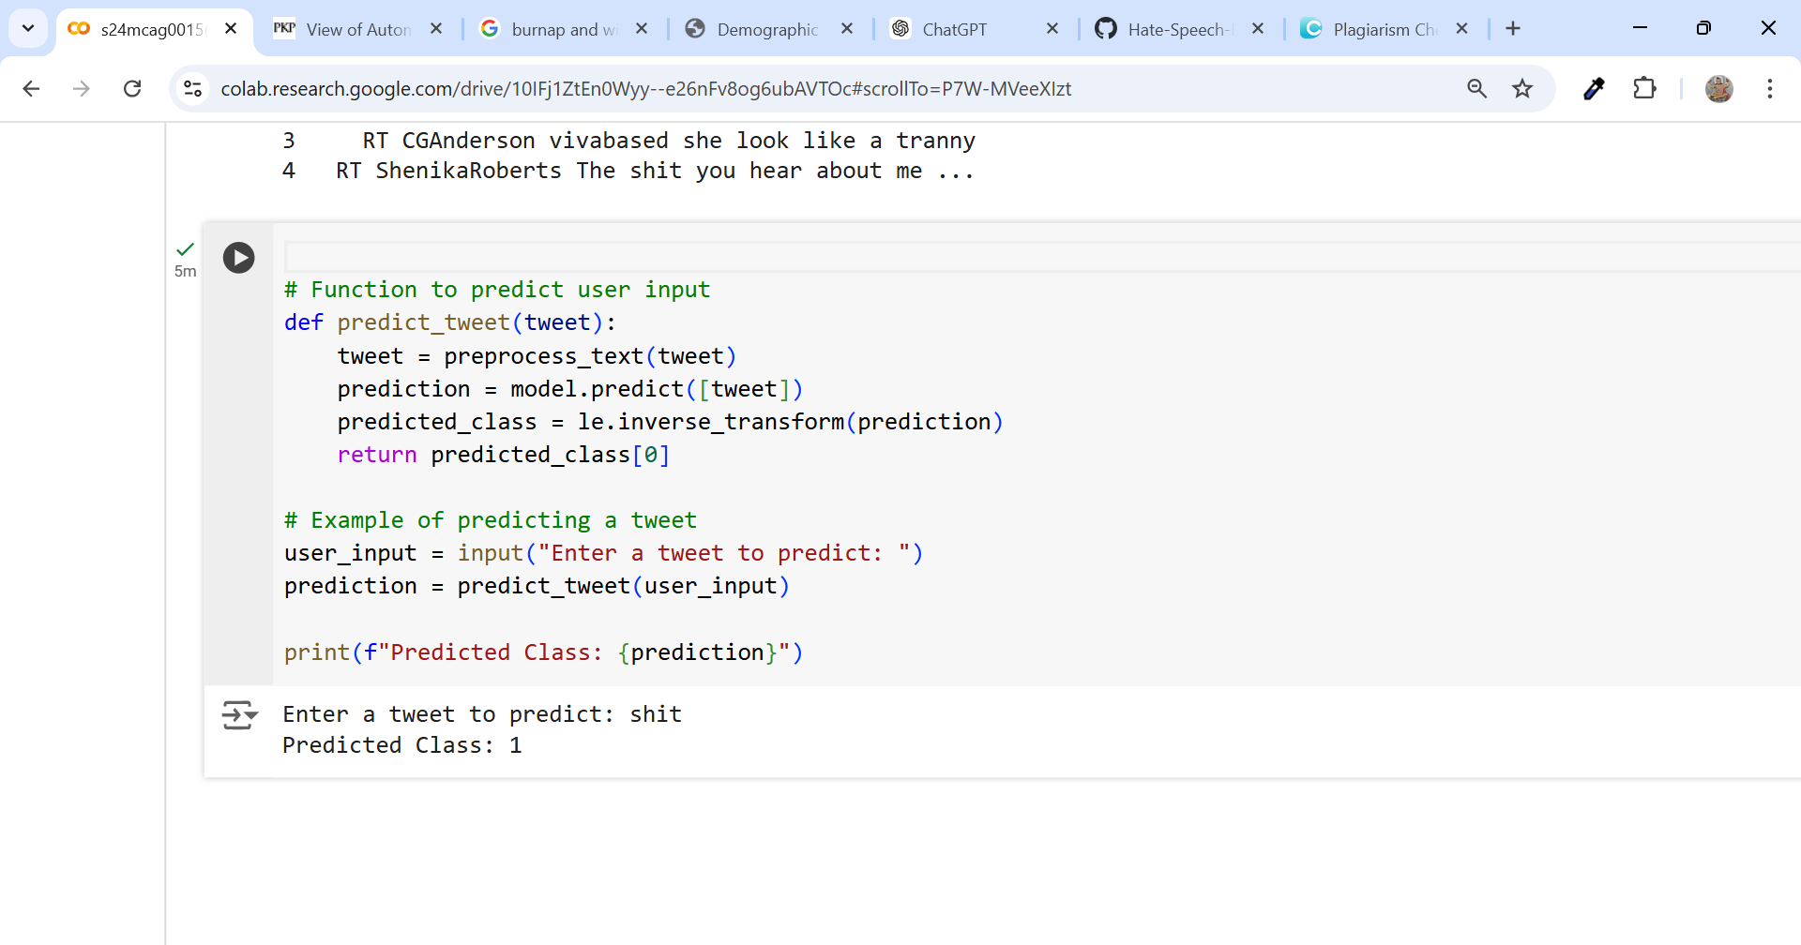

**Fig predicting result for Offensive Language**

**User input –** shit

**Predicted class –** 1 (Offensive Language)

**Case-2 Neutral –** class 2

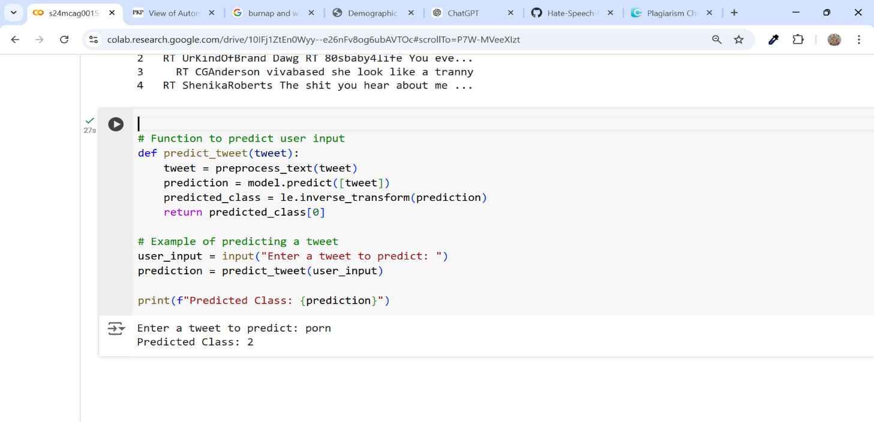

**Fig predicting result for Neutral**

**User input –** shit

**Predicted class –** 1 (Offensive Language)

**Conclusion:**

The study highlights the difficulty associated with detecting hate speech on Twitter due to the ambiguous nature of the language and context. It also highlights that offensive language is regularly misclassified as hate speech, perhaps due to a very broad definition. Importantly, the model was able to discriminate between hate speech and offensive language accurately, reducing errors present in previous research.

**CONCLUSION**

If we mix up the hate speeches and offensive languages, for the first time we may think wrong that people are using hate speech, but in reality their intension are just being offensive (mistakes in the lower part of Figure 1) and we might not notice real hate speech when it happens (mistakes in the upper part of Figure 1). Since hate speech can be harmful, it’s important to tell the difference between the two. Words that seem offensive can help find hate speech, but they don’t always do a good job. In fact, only a few tweets marke by the Hatebase list were considered real hate speech by people who looked at them.

Automated methods can usually separate these types well, but when we study the results closely, we see that some words can either help or make it harder to correctly label tweets. Some words are better for finding hate speech. Words like fg, btch, and ngga can be used in both hate speech and offensive language, but words like fggot and n*gger are mostly used in hate speech. Many tweets that are the most hateful contain several racist or homophobic slurs, making them easier to identify. But if hate speech doesn’t have these bad words, it’s harder to figure out. So, we need to find data where people use hate speech without using certain bad words.

Our results also show that hate speech can be used in different ways: it can be directed at someone or a group of people, it can be said to no one in particular, or it can happen in a conversation between people. Future research should look at these different ways and the situations where hate speech happens. We should also learn more about the people who use hate speech, including why they do it and the social groups they belong to.

Hate speech is hard to define, and it’s not all the same. The way we classify hate speech depends on our own views. People usually see racist and homophobic slurs as hateful but often think sexist language is just offensive. Our results show that people are good at spotting the worst forms of hate speech, like racism and homophobia, but it’s important to understand the biases in our systems, and future work should focus on fixing these biases.

**FUTURE SCOPE**

**Context-Aware Classification**

Improvement in Contextual Understanding: Future models should incorporate more advanced techniques for contextual analysis, addressing how words like "gay" or "bitch" may vary in meaning based on context. Enhancing models with deeper semantic and contextual comprehension will minimize false positives and improve classification accuracy for borderline cases.

Sentiment & Intent Detection: The ability to differentiate between hate speech, offensive language, and neutral content will be further enhanced by incorporating sentiment and intent detection, helping machines better understand nuances like sarcasm or satire.

**Expansion of Data Sources**

**Diverse Datasets:** Collect data from more varied sources to include different languages and dialects (e.g., Hinglish in your case) to improve model robustness. This will also aid in detecting nuanced forms of hate speech, which are often context-specific.

**User Characteristics**: Including demographic data (when possible) could further improve the classification model, though ethical considerations around privacy and bias must be handled carefully.

Fine-Grained Classification

**Subtype Classification**: Moving beyond the current binary or multi-class categories, it would be beneficial to categorize hate speech into subtypes (racist, sexist, homophobic, etc.), helping to identify specific forms of harmful language.

**Granularity of Offensive Language**: Identifying and differentiating between casual offensive language and deeply harmful hate speech would allow for more targeted interventions and responses by social media platforms.

**Bias Mitigation in Algorithms**

**Addressing Social Biases**: It's crucial that future models be regularly audited to ensure they do not amplify societal biases. Research into bias mitigation will help ensure that models don't disproportionately flag certain groups or individuals while missing others.

**Model Transparency**: Developing transparent models with explainability features will help detect and correct any unintended biases in the hate speech detection system.

Cross-Platform Analysis

**Multimedia Data**: Incorporating images, videos, and other media types alongside textual data could provide a more comprehensive approach to detecting offensive content, especially since hate speech can sometimes be conveyed in non-textual formats.

Cross-Platform Consistency: Ensuring that hate speech detection systems work effectively across different social media platforms will be essential for large-scale applications.

Real-Time Detection and Response

**Improved Real**- Time Monitoring: Integrating real-time detection systems with automated reporting and flagging mechanisms could reduce the time it takes for harmful content to be removed from platforms, ensuring a safer online environment.

Automated Content Moderation Tools: Future advancements could lead to more sophisticated systems that not only detect but also suggest or implement actions like temporary suspension or warning notifications to users spreading harmful content.

**REFERENCES**

Davidson, T., Warmsley, D., Macy, M., & Weber, I. (2017). Automated Hate Speech Detection and the Problem of Offensive Language. *Proceedings of the International AAAI Conference on Web and Social Media*, *11*(1), 512-515. –

https://ojs.aaai.org/index.php/ICWSM/article/view/14955

**Bird, s., Loper, E., & Klein, E. (2009). Natural Language Processing with Python. O'Reilly Media.**

This book teaches how computers can understand and work with human language using Python programming.

**Burnap, P., & Williams, M. L. (2015). Cyber hate speech on Twitter: Using machines to find harmful posts. Policy & Internet, 7(2), 223-242.**

This study shows how computers can help find hurtful messages (hate speech) on Twitter.

**Hutto, C. J., & Gilbert, E. (2014). VADER: A simple rule-based model for social media sentiment. ICWSM.**

This research explain a simple tool that helps computers understand if social media posts are happy, sad, or angry.

**Kwok, I., & Wang, y. (2013). Finding hate in tweets. AAAI.**

This paper explains a popular tool that helps computers learn from data, making it easierto build smart systems.